Contents

Python Programming- Lecture 1 5

# 1 strings 5

More about ‘type’. 5

# 2. string manipulation 5

# 3. string is immutable 6

# 4. strings and integer 7

5. string methods 7

# 6. strings slice 8

7. strings tuple of arguments (this is old style) 9

8. strings format (this is new style) 9

9. Formatted string literals 10

10. If statement 10

11. Function Calls 11

12.def function_name(parameters): BLOCK 12

13. Function parameters and arguments 12

14. Function without Returns 13

14.1. With ‘return’ 13

15. Function Returns tuple 14

16. 'from' function 14

# 15

17. Function Checking type of arguments-recursive 16

18. Default arguments/Function overloading 16

19. Global/Local variables 17

20. Some math functions: 18

# 20.1. Arguments of Trigonometric functions are in radian as default. 19

21. Modules in python 19

numpy: 19

os.MFD_HUGE_256MB: 20

scipy: 20

#22. Matrix operations 21

23. Bassel functions- theory 22

Visualization: 24

24. Plot Bessel function of 1st and 2nd type: 25

25. Integrate f(x) between limits, ∫baf(x)dx 27

import numpy as np 27

# 25.1 fig, ax = plt.subplots() 29

25.2 dblquad, tplquad meaning 30

26. Integration of Bassel Function. 32

27. Double Integration 33

27.1 what is ‘pandas’? 34

27.2 from IPython.display import Image 35

27.3 Compare NumPy, SciPy and math 36

28. Some more matrix operations 39

28.1 What is SVD? 41

29. Data visualization-random curve and fill 41

29.1 np.random.randn() & np.random.random() 42

30. Ex: Ball falling under gravity. 44

[(30.1) x=2+ np.array([[1, 2, 3]])+np.array([[2, 5, 9]]) what is the result? 47](#_Toc148316712)

(30.2) How to use column vectors and row vectors. 47

30.3. The comma after h1 and h2 in the lines of code? 48

31. Spring-mass damper system. 50

32. Ex: Spring-mass-damper with forcing 54

33. Spring-mass-damper with direct integration 57

33.1 More about odeint function. 59

34. Laplace equation solution 60

34.1 T = np.empty((lenX, lenY)). Can we place ‘zeros’ in place of ‘empty’. 63

34.2 How boundary conditions are assigned in 2D grid. 63

34.3. X, Y = np.meshgrid(np.arange(0, lenX), np.arange(0, lenY)) 64

34.4. plt.contourf(X, Y, T, colorinterpolation, cmap=colourMap) 66

35. Class project: Temperature distribution over plate. 66

36. lists, loops, string manipulation, and basic Python syntax. 69

#Addition with and without Numpy. 73

36.1. String are immutable in python, but lists are not? 79

# Python Programming- Lecture 1

## # 1 strings

s='hello'

print(s)

type(s)

print(type(s))

* **hello**
* **<class 'str'>**

# 1.2 strings

s='hello'

print(s)

type(s)

* **hello**
* **str**

## More about ‘type’.

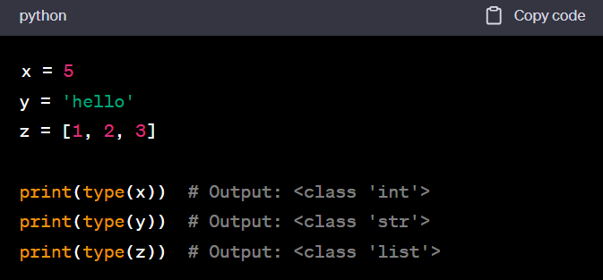

There are situations where knowing the type explicitly is necessary, such as when dealing with certain operations or debugging.

## # 2. string manipulation

s="hello"

print(s)

print(s[2])

#Accessing individual characters by index. In Python, indexing starts at 0.

print(s[0],s[1],s[2],s[3],s[4])

# Accessing and printing characters using multiple indices.

print(s[0],s[1],s[-1],s[-2],len(s))

# Accessing characters using both positive and negative indices. Negative indices for last character start from -1. the length of the string is denoted by len(s).

print(s+" world")

# This concatenates the string "hello" with the string " world" and prints the result. The output will be "hello world".

* **Hello**
* **L**
* **h e l l o**
* **h e o l 5**
* hello world

## # 3. string is immutable

s='Hello'

print(s)

type(s)

s[1]='b'   # see this statement itself highlighted

* TypeError: 'str' object does not support item assignment

Explanation: you're trying to assign a new value ('b') to the character at index 1 of the string s. However, this will result in an error because strings in Python are immutable.

If you need to modify a string, you can create a new string with the desired changes. For example.

s = 'Hello'

s = s[:1] + 'b' + s[2:]

print(s)

* **Hbllo**

**Explanation:**

**s[:1]**: This is a slicing operation that extracts the substring from the beginning of the string up to, *but not including,* the character at index 1. In this case, it takes the first character 'H'.

**s[2:]**: This is another slicing operation that extracts the substring starting from index 2 *(including)* to the end of the string. In this case, it takes the characters 'llo'.

## # **4. strings and integer**

s="hello"

num=10

print(num)

**print(s+num)**

* **TypeError: can only concatenate str (not "int") to str**

In Python, you can't directly concatenate a string and an integer using the + operator without converting the integer to a string first.

Here's an updated version of your code:

s = "hello"

num = 10

print(num)

# Convert the integer to a string before concatenating

**print(s + str(num))**

* **10**
* **hello10**

5. string methods

s1="HelloTarif"

print(s1.lower())

print(s1.upper())

#Converts all characters in the string to uppercase.

print(s1.strip())

#Removes leading and trailing whitespaces from the string.

print(s1.isalpha())

#Checks if all characters in the string are alphabetic.

print(s1.isdigit())

#Checks if all characters in the string are digits.

print(s1.isspace())

#Checks if all characters in the string are whitespaces.

print(s1.replace(s1,'old'))

#Replaces the entire string with the string 'old' (this might not be the intended behavior; it seems like you might want to replace a part of the string).

print('a,b,c'.split(','))

#**Splits the string** 'a,b,c' into a list ['a', 'b', 'c'] based on the comma delimiter.

print(':'.join(['a','b','c']))

#**Joins the elements** of the list ['a', 'b', 'c'] into a string using the colon (':') as a delimiter.

* **hellotarif**

**HELLOTARIF**

**HelloTarif**

**True**

**False**

**False**

**old**

**['a', 'b', 'c']**

**a:b:c**

## # 6. strings slice

s="Hello"

print(s[1:3])

#Prints characters from index 1 to index 2 **(excluding 3)**. The result is "el".

print('\n')

#The **'\n'** is used to print a **newline character**, which creates a blank line between the outputs for better readability.

print(s[1:])

print('\n')

print(s[-4:3])

#Prints characters from index -4 to index 2 (excluding 3). Negative indices count from the end of the string. The result is "el".

* el
* ello
* el

7. strings tuple of arguments (this is old style)

str1='hello %s, %d' % ('world',10)

print(str1)

* hello world, 10

**Explanation**:

example of old-style string formatting in Python. In the old style, the **%** operator is used to format a string with values provided in a tuple on the right side of the **%** operator.

**'%s'** and **'%d'** are placeholders for string and integer values, respectively.

## 8. strings format (this is new style)

str2='Hello {}, {}'.format('world',10)

print(str2)

#**Basic String Formatting.** This uses placeholders **{}** in the string and fills them in order with the values provided in the **format()** method.

str3 = 'Hello {wd}, {num}'.format(num=10, wd='World')

print(str3)

#**Named Placeholder Formatting.** Here, named placeholders **{wd}** and **{num}** are used, and their values are specified in the **format()** method using keyword arguments.

str4 = 'Hello {wd:10}, {num:.3f}'.format(num=10.0, wd='World')

print(str4)

#**Formatting with Width and Precision.** This example shows how to format with width and precision. **{wd:10}** specifies a **minimum width** of 10 characters for the **wd** placeholder, and **{num:.3f}** specifies a floating-point number with **3 digits** after the decimal point for the **num** placeholder.

* Hello world, 10

Hello World, 10

Hello World , 10.000

## 9. Formatted string literals

w = 'World'

num = 10

print(f'Hello {w}, {num}')

print(f'Hello {w}, {num + num}')

* **Hello World, 10**

**Hello World, 20**

**Explanation:**

Your code is using formatted string literals, often referred to as f-strings. This feature was introduced in Python 3.6, providing a concise and readable way to format strings.

**f'Hello {w}, {num}'**: This is an f-string where expressions inside curly braces **{}** are evaluated and replaced with their values. In this case, **{w}** is replaced with the value of the variable **w** ('World'), and **{num}** is replaced with the value of the variable **num** (10).

**f'Hello {w}, {num + num}'**: Here, an expression **{num + num}** is evaluated, and the result (20) is inserted into the string.

10. If statement

num = 40

if num < 5:

  print('num is smaller than 5')

if num > 5:

  print('num is greater than 5')

elif num == 5:

  print('num is 5')

else:

  print('num is smaller than 5')

* **num is greater than 5**

11. Function Calls

print(type(32))

#Prints the type of the number 32. The output will be **<class 'int'>**.

type(32)

print(int(32))

#Converts the number 32 to an integer using the **int()** function and prints it.

#int('Hello')

# If you want to convert a string to an integer, the string must contain a valid integer representation. it will raise a **ValueError.**

int(-2.3)

print(int(-2.3))

#The output is -2 because the decimal part of -2.3 is truncated, and only the whole number part is retained. It's important to note that the conversion doesn't round the number; it simply removes the decimal part towards zero.

import math

# Imports the **math** module.

print(math.sin(3.1416))

print(math.cos(3.1416))

print(math.tan(3.1416))

print(math.acos(-1))

print(math.sqrt(2))

#help('math')  # try this too

* **<class 'int'>**

**32**

**-2**

**-7.346410206643587e-06**

**-0.9999999999730151**

**7.346410206841829e-06**

**3.141592653589793**

**1.4142135623730951**

12.def function_name(parameters): BLOCK

def print_name():

  print("I'm Raja")

  print("I'm Blah Blah Blah")

print_name()

* **I'm Raja**

**I'm Blah Blah Blah**

**Explanation**:

**def print_name():**: This line defines a function named **print_name** with no parameters. It consists of two **print** statements that will display messages when the function is called. The colon **:** indicates the start of the function block.

13. Function parameters and arguments

def print_twice(arg1):

  print(arg1)

  print(arg1)

print_twice('Spam' * 4)

* **SpamSpamSpamSpam**

**SpamSpamSpamSpam**

If you intend to use **math.pi (for printing pi twice using this function)**, you need to import the **math** module first. See below:

# 13.1 Function parameters and arguments

import math

def print_twice(arg1):

  print(arg1)

  print(arg1)

print_twice(math.pi)

=> **3.141592653589793**

**3.141592653589793**

14. Function without Returns

def print_twice(arg1):

  print(arg1)

  print(arg1)

result = print_twice('Bing')

print(result)

* **Bing**

**Bing**

**None**

In this case, **print_twice** doesn't explicitly return a value (implicitly returns **None**). The function can perform actions, such as printing, but it doesn't provide a result that can be assigned to a variable or used in expressions elsewhere.

14.1. With ‘return’

def print_twice(arg1):

    print(arg1)

    print(arg1)

**return** arg1 * 2

result = print_twice('Bing')

print(result)

**=> Bing**

**Bing**

**BingBing**

Here, **print_twice** not only performs actions (printing) but also returns a value (**arg1 * 2**). This returned value can be assigned to a variable (**result** in this case) and used elsewhere in your code.

15. Function Returns tuple

def print_twice(arg1,arg2):

#Defines a function named **print_twice** that takes two arguments

  return arg1,arg2

#The function returns a tuple containing the values of **arg1** and **arg2**.

res1,res2 = print_twice('Bing','soumys')

#Calls the function with arguments **'Bing'** and **'soumys'** and unpacks the returned tuple into the variables **res1** and **res2**.

print(res1)

print(res2)

print(res1, res2)

=> **Bing**

**soumys**

**Bing soumys**

**Explanation:**

The function **print_twice** returns a tuple. A tuple is a data structure in Python that is similar to a list but is immutable, meaning its elements cannot be changed after it is created. In this case, the function returns a tuple containing two elements: **arg1** and **arg2**.

The line **return arg1, arg2** is equivalent to **return (arg1, arg2)**. The parentheses are optional when returning multiple values, and Python automatically creates a tuple.

The returned tuple **('Bing', 'soumys')** is automatically unpacked into the variables **res1** and **res2**. As a result, **res1** gets the value **'Bing'**, and **res2** gets the value **'soumys'**. Then, you print these values individually.

16. 'from' function

In Python, when you import a module using **import math**, you need to reference items from that module using the module name as a prefix, like **math.pi**. If you want to directly import specific items from a module without needing to use the module name as a prefix, you can use the **from** keyword. E.g. from math import pi, cos

# 16.1 Importing without ‘from’

import math

print(math)

#output indicates that **math** is a built-in module in Python. It's part of the standard library, and **<module 'math' (built-in)>** is just a representation of the **math** module object.

print(math.pi)

#print(pi)

#This will not work here without math. Prefix. Shows “NameError: name 'pi' is not defined”

=> **<module 'math' (built-in)>**

**3.141592653589793**

# 16.2 Importing with 'from' function

from math import pi

print(pi)

from math import *

# In Python, the **\*** character, when used in the context of importing with the **from** statement, is a wildcard that means "import everything." It is often referred to as a "star import." You are indeed importing all names from the **math** module into the current namespace using the wildcard **\***.

cos(pi)

**=> 3.141592653589793**

**-1.0**

17. Function Checking type of arguments-recursive

def factorial (n):

  if not isinstance(n, int):

    print('Factorial is only defined for integers.')

    return None

# **isinstance(n, int)**: Checks if **n** is an integer. If it's not, it prints an error message and returns **None**.

  elif n < 0:

   print('Factorial is not defined for negative integers.')

   return None

  elif n == 0:

    return 1

  else:

    return n * factorial(n-1)

factorial(5)

* **120**

18. Default arguments/Function overloading

def func1(arg1, arg2=None):

  if arg2 is None:

    print(arg1)

  else:

    print(arg1, arg2)

func1('hello')

func1('hello', 'world')

* **hello**

**hello world**

**Explanation:**

In the definition of **func1**, **arg2=None** makes **arg2** an optional parameter, and its default value is **None**. When you call the function without providing a value for **arg2** (as in **func1('hello')**), it uses the default value, and the condition **if arg2 is None:** is true. In this case, it prints only **arg1**.

When you call the function with both arguments (as in **func1('hello', 'world')**), it prints both **arg1** and **arg2**.

19. Global/Local variables

global_var = 1

def func1():

  global_var = 2  # This is not a global variable, but a local variable.

func1()

global_var

* **1**

**Explanation:**

You have a global variable **global_var** with a value of **1**, and you define a function **func1** that has a local variable with the same name **global_var** with a value of **2**.

When you call **func1()**, it doesn't modify the global variable **global_var**. Instead, it creates a new local variable with the same name that exists only within the scope of the function.

After calling **func1()**, if you print **global_var**, it will still refer to the global variable outside the function. Therefore, the output will be 1.

If you want to modify the global variable within the function, you need to use the **global** keyword:

global_var = 1

def func1():

  global global_var

  global_var = 2

func1()

# Remember one thing. This ‘ func1()’ is used to ‘call’ the function. It is necessary. If you comment out this line, it will still show output as 1.

global_var

* **2**

20. Some math functions:

import math

a = 2

b = 5

c = (a**2 + b**2)**0.5

d = math.sqrt(c)

print('hypoteneous length =', c)

print('sq root d =', d)

e = math.log(d)

f = c * d

g = c / d

h = a * math.sin(b)

print('multiplication =', f)

print('division =', g)

print('sin func =', h)

* **hypoteneous length = 5.385164807134504**

**sq root d = 2.320595787106084**

**multiplication = 12.496790764308276**

**division = 2.3205957871060834**

**sin func = -1.917848549326277**

### # 20.1. Arguments of Trigonometric functions are in radian as default.

In Python's **math.sin** function, the argument is expected to be in radians. Therefore, if you want to calculate the sine of an angle given in degrees, you need to convert the angle from degrees to radians using the **math.radians** function.

So, in the line:

h = a * math.sin(b)

If **b** represents an angle in degrees, you should modify it like this:

**h = a * math.sin(math.radians(b))**

This ensures that the **math.sin** function receives the angle in radians, which is the expected format.

## 21. Modules in python

### numpy:

This module provides a variety of mathematical functions, such as array manipulation, linear algebra, and Fourier transforms.

Specifically, **numpy.linalg** module provides a variety of linear algebra functions, such as matrix multiplication, inversion, and eigenvalue decomposition.

import numpy as np

import numpy.linalg as LA

# This imports NumPy and renames the **numpy.linalg** module to **LA** for convenience.

# Create a NumPy matrix and print that

A = np.array([[1, 2], [3, 4]])

print('A=',A)

# Calculate the inverse of the matrix

B = LA.inv(A)

# Print the inverse matrix

print('B=',B)

**A= [[1 2]**

**[3 4]]**

**B= [[-2. 1. ]**

**[ 1.5 -0.5]]**

os.MFD_HUGE_256MB:

This constant represents the size of a huge memory file descriptor, which is 256 MB. **‘**os’ module provides functions for interacting with the operating system, such as creating and deleting files and directories, opening and closing files, and running other programs.

### scipy:

This module provides a variety of scientific computing functions, such as statistical analysis, signal processing, and optimization.

import numpy as np

import scipy.stats as stats

# Imports the **stats** submodule from the SciPy library and renames it to **stats.**

# Create a NumPy array of random numbers

data = np.random.randn(1000)

# Generates an array of 1000 random numbers from a standard normal distribution. Each number in this array is drawn independently from a Gaussian distribution with a mean (average) of 0 and a standard deviation of 1.

# Calculate the mean and standard deviation of the data

mean = stats.tmean(data)

std = stats.tstd(data)

# Print the results

print("Mean:", mean)

print("Standard deviation:", std)

* **Mean: 0.01063247408029411**

**Standard deviation: 0.9726377211855272**

## #22. Matrix operations

import numpy as np

from scipy.linalg import inv

from numpy import array

# You may use from numpy import *. But, we import the **array** function from NumPy. Note that wildcard imports (**\***) are avoided to reduce the risk of naming conflicts.

M1 = array([[1, 2, 3], [4, 5, 6], [7, 8, 9]])

M2 = array([[1, 4, 3], [4, 7, 6], [7, 12, 9]])

M3 = np.dot(M1, M2)

# It's important to note that the result of **A * B** is an element-wise multiplication, not the standard matrix multiplication. If you want to perform standard matrix multiplication, you should use **np.dot(M1, M2)** or the M1 **@ M2** operator.

M4 = M1[1]

M5 = M1 * M4

# This is not a proper matrix multiplication. Element-wise multiplication, but note that M4 is a row vector. So, this is of no-meaning.

M6 = inv(M2)

# Use the inv function from scipy.linalg for matrix inversion

print('\n M1=', M1)

print('\n M2=', M2)

print('\n M3=', M3)

print('\n M4=', M4)

print('\n M5=', M5)

print('\n M6=', M6)

* **M1= [[1 2 3]**

**[4 5 6]**

**[7 8 9]]**

**M2= [[ 1 4 3]**

**[ 4 7 6]**

**[ 7 12 9]]**

**M3= [[ 30 54 42]**

**[ 66 123 96]**

**[102 192 150]]**

**M4= [4 5 6]**

**M5= [[ 4 10 18]**

**[16 25 36]**

**[28 40 54]]**

**M6= [[-7.50000000e-01 2.96059473e-16 2.50000000e-01]**

**[ 5.00000000e-01 -1.00000000e+00 5.00000000e-01]**

**[-8.33333333e-02 1.33333333e+00 -7.50000000e-01]]**

## 23. Bassel functions- theory

Bessel functions are a family of mathematical functions that are solutions to Bessel's differential equation. The Bessel differential equation is given by:

***x*2*y*′′+*xy*′+(*x*2−*n*2)*y*=0**

where *y*′′ is the second derivative of *y* with respect to *x*, *y*′ is the first derivative, *n* is a parameter, and *x* is the independent variable.

The solutions to the Bessel differential equation are called Bessel functions of the first kind, and they are denoted by *Jn*​*u*(*z*). There are also other types of Bessel functions, such as Bessel functions of the second kind, *Yn*​*u*(*z*), and modified Bessel functions, *In*​*u*(*z*) and *Kn*​*u*(*z*).

Bessel functions can be expressed in a variety of ways, including infinite series, integrals, and continued fractions. They can also be computed numerically using a variety of algorithms.

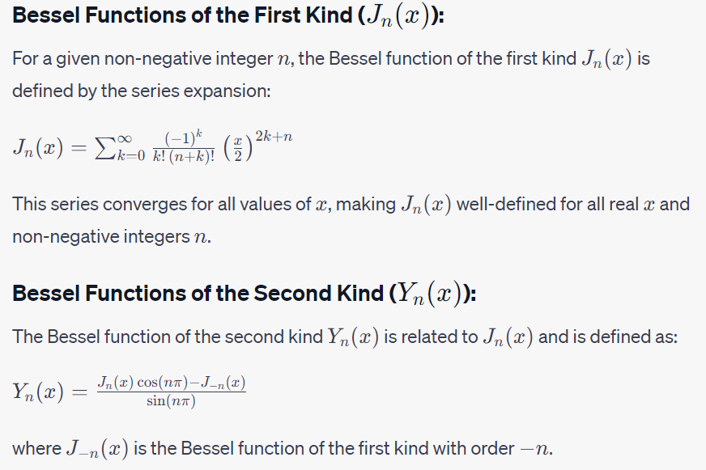

Here are some mathematical properties of Bessel functions:

Bessel functions of the first kind are continuous and infinitely differentiable for all *z* and *nu*.

Bessel functions of the first kind are oscillatory functions, meaning that they have an infinite number of zeros.

The zeros of Bessel functions of the first kind are interlaced, meaning that the zeros of *Jnu*+1​(*z*) are always located between the zeros of *Jnu*​(*z*).

Bessel functions of the first kind satisfy the following recurrence relation:

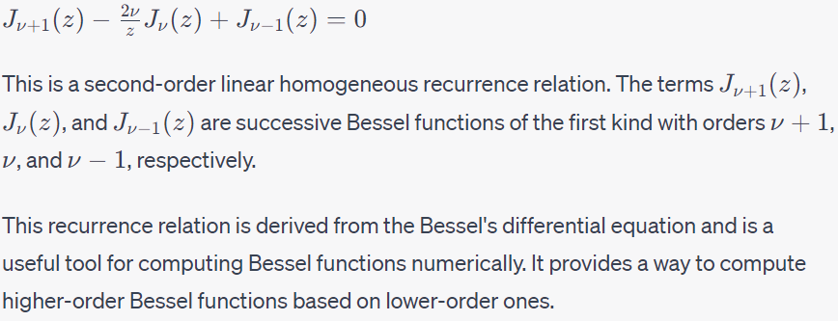

**Physical Interpretation:**

In physical terms, these functions often arise in problems involving circular or cylindrical symmetry. For example:

**Vibrations of Circular Membranes:** In the context of a circular drumhead, *Jn*​(*x*) describes the radial displacement of the drumhead at position *x* for a given mode *n*.

**Heat Conduction:** In the context of heat conduction in a cylindrical object, *Jn*​(*x*) can describe the temperature distribution at a radial position *x* for a given mode *n*.

**The Schrödinger equation** for a hydrogen atom.

**The Helmholtz equation** in spherical coordinates.

### Visualization:

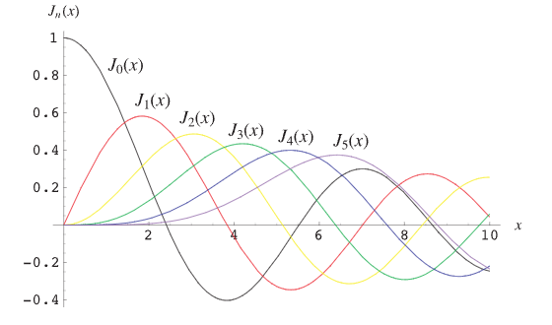

For more detail, visit <https://mathworld.wolfram.com/BesselFunctionoftheFirstKind.html>

## 24. Plot Bessel function of 1st and 2nd type:

import numpy as np

import matplotlib.pyplot as plt

from scipy.special import jn, yn

#Import necessary libraries. **numpy** for numerical operations, **matplotlib**.**pyplot** for plotting, and **jn** and **yn** functions from **scipy**.**special** for Bessel functions of the first and second kinds.

# Define parameters

x = np.linspace(0, 20, 100)  # Values of x

n_values = [0, 1, 2, 3]  # Orders of Bessel functions

# Plot Bessel functions of the first kind (J_n(x))

plt.figure(figsize=(12, 6))

#creating a figure using Matplotlib in Python with a specified figure size of 12 inches in width and 6 inches in height.

plt.subplot(1, 2, 1)

#Create the first subplot in a 1x2 grid (1 row, 2 columns), and set the current subplot to the first one.

for n in n_values:

    plt.plot(x, jn(n, x), label=r"$J_{%d}(x)$" % n)

#Loop through the orders in **n_values** and plot Bessel functions of the first kind for each order. The **label** argument is used for legend labeling. **plt.plot()** function is typically used to plot a line graph.

# **jn(n, x)**: This is the Bessel function Jn​(x) with order n evaluated at the given x-values.

#**label=r"$J_{%d}(x)$" % n:** This is a raw string (indicated by the **r** prefix) that uses LaTeX-style formatting. The **%d** is a placeholder for an integer, which will be replaced by the value of **n**.

plt.title("Bessel Functions of the First Kind ($J_n(x)$)")

plt.xlabel("x")

plt.ylabel("$J_n(x)$")

plt.legend()

plt.grid(True)

#Add title, xlabel, ylabel, legend, and grid to the first subplot.

# Plot Bessel functions of the second kind (Y_n(x))

plt.subplot(1, 2, 2)

for n in n_values:

    plt.plot(x, yn(n, x), label=r"$Y_{%d}(x)$" % n)

plt.title("Bessel Functions of the Second Kind ($Y_n(x)$)")

plt.xlabel("x")

plt.ylabel("$Y_n(x)$")

plt.legend()

plt.grid(True)

plt.tight_layout()

plt.show()

#Without **tight_layout()**, subplots might overlap or not be evenly spaced, especially when you have multiple subplots.

#The **show()** function is used to display the plot. When you run a Matplotlib script in interactive mode, you don't always need to call **show()** explicitly because the plot will be displayed automatically. However, in certain environments (like scripts or non-interactive modes), you may need to call **show()** to display the plot.

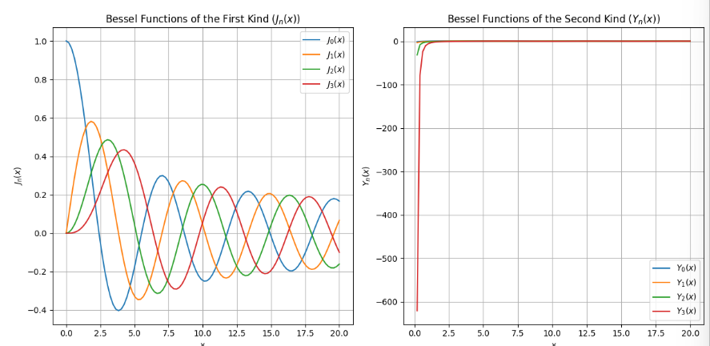

## 25. Integrate f(x) between limits, ∫baf(x)dx

 ##Integrate f(x) between limits, $\displaystyle \int_a^b f(x) dx$

## import numpy as np

import matplotlib.pyplot as plt

from scipy.integrate import quad

#**quad** function from **scipy.integrate** for **numerical** integration. See 25.2 for more.

def f(x):

    a = 1

    return a * x**2

#Define a function **f(x)** that represents the function f(x)=x2.( though, local variable a is not necessary to include, as its value=1).

# Define integration bounds

x_lower = 0

x_upper = 1

# Perform the integration

val, abserr = quad(f, x_lower, x_upper)

print("Integral =", val, ", Absolute error =", abserr)

#Use the **quad** function to perform numerical integration of the function f(x)=x2 over the specified bounds (**x_lower** to **x_upper**). The result (**val**) is the definite integral, and **abserr** is the estimated absolute error.

# Plot the function

n = 256

X = np.linspace(x_lower, x_upper, n, endpoint=True)

Y = f(X)

#This line uses NumPy's **linspace** function to create an array of **n** equally spaced points between **x_lower** and **x_upper**, inclusive. The **endpoint=True** argument specifies that the endpoint (i.e., **x_upper**) should be included in the array.

# Plotting

fig, ax = plt.subplots() **#See below**

ax.plot(X, Y, label='f(x) = x^2')

# The **label** parameter is set to 'f(x) = x^2' for use in the legend.

ax.fill_between(X, 0, Y, alpha=0.2, color='blue')

# X=> This is the x-values of the points defining the horizontal axis. #0,Y=> The area between the lower curve (defined by **0**) and the upper curve (defined by **Y**) will be filled.

# **alpha=0.2 =>** This parameter controls the transparency of the filled area. Alpha=0.0 means totally transparent, alpha=1.0 means opaque.

ax.legend()

ax.set_title('Plot of f(x) = x^2')

ax.set_xlabel('x')

ax.set_ylabel('f(x)')

# Additional plotting commands

plt.plot(X, Y, '-', color='r', linewidth=6)

# **'-'** represents a solid line. Other line styles include **'--'** for dashed lines, **':'** for dotted lines, and **'-.'** for dash-dot lines.

# **'r'** represents red. You can use various color representations such as **'b'** for blue, **'g'** for green, **'k'** for black, **'c'** for cyan, and so on. Additionally, you can specify colors using RGB values like **(0.8, 0.2, 0.1)**.

# Show the plot

plt.show()

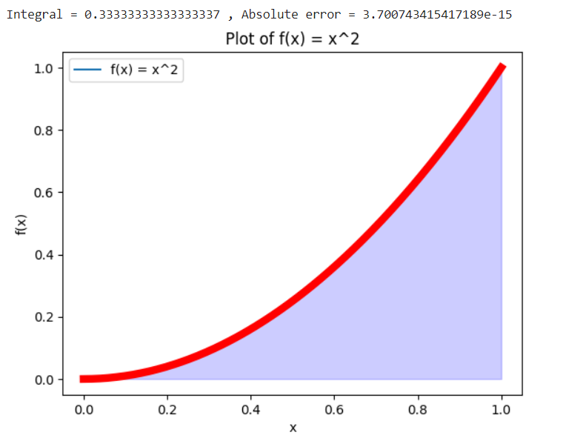

### # 25.1 fig, ax = plt.subplots()

The line fig, ax = plt.subplots() creates a new figure (fig) and a single set of subplots (ax). In other words, it creates a new window and a single plot within that window. This line is using Python's tuple unpacking to assign the two returned objects (**fig** and **ax**) to the variables **fig** and **ax**.

The plt.subplots() function takes two optional arguments: nrows and ncols, which specify the number of rows and columns of the subplot grid. If only one argument is provided, then a single subplot is created. If two arguments are provided, then a grid of subplots is created.

In the example you provided, the plt.subplots() function is called with no arguments. This means that a single subplot will be created. The function returns two objects: a figure object (fig) and an axes object (ax).

The figure object represents the entire window, while the axes object represents the single plot within the window.

Once the figure and axes objects have been created, you can use the **ax** object to plot data, set labels, titles, and customize the appearance of your plot.

### 25.2 dblquad, tplquad meaning

In Python, particularly in the context of scientific computing and numerical integration, **dblquad** and **tplquad** refer to functions provided by the SciPy library for double and triple integration, respectively.

1. **dblquad**:

The **dblquad** function is used for double integration. It has the following syntax:

scipy.integrate.dblquad(func, a, b, gfun, hfun)

* + **func**: The integrand function of two variables.
  + **a**, **b**: The lower and upper limits of integration for the variable *x*.
  + **gfun**, **hfun**: These are functions defining the lower and upper limits of integration for the variable *y* as functions of *x*.

Here's an example:

from scipy import integrate

def integrand(x, y):

    return x * y

result, error = integrate.dblquad(integrand, 0, 1, lambda x: 0, lambda x: 2)

print(result)

* **0.9999999999999999**

This example computes the double integral of *xy* over the region where 0≤*x*≤1 and 0≤*y*≤2.

1. **tplquad**:

The **tplquad** function is used for triple integration. Its syntax is as follows:

scipy.integrate.tplquad(func, a, b, gfun, hfun, qfun, rfun)

* + **func**: The integrand function of three variables.
  + **a**, **b**: The lower and upper limits of integration for the variable *x*.
  + **gfun**, **hfun**: Functions defining the lower and upper limits of integration for the variable *y* as functions of *x*.
  + **qfun**, **rfun**: Functions defining the lower and upper limits of integration for the variable *z* as functions of *x* and *y*.

Here's an example:

from scipy import integrate

def integrand(x, y, z):

    return x * y * z

result, error = integrate.tplquad(integrand, 0, 1, lambda x: 0, lambda x: 2, lambda x, y: 0, lambda x, y: 3)

# **0, 1**: These are the lower and upper limits of integration for the variable **x**.

**lambda x: 0, lambda x: 2**: These are the functions defining the lower and upper limits of integration for the variable **y**. The limits are expressed as functions of **x**.

**lambda x, y: 0, lambda x, y: 3**: These are the functions defining the lower and upper limits of integration for the variable **z**. The limits are expressed as functions of both **x** and **y**.

print(result)

* **4.5**

This example computes the triple integral of *xyz* over the region where 0≤*x*≤1, 0≤*y*≤2, and 0≤*z*≤3.

These functions are useful when you need to numerically integrate functions of multiple variables over specified regions.

## 26. Integration of Bassel Function.

import numpy as np

from scipy.integrate import quad

from scipy.special import jn

# Importing necessary libraries for numerical operations, numerical integration and Bessel functions.

# Define the Bessel function to integrate

def integrand(x):

    n = 0  # Replace with the desired order of the Bessel function. Here, I took 0th order.

    return jn(n, x)

# Define integration bounds

x_lower = 0

x_upper = 10 # Adjust the upper limit as needed

# Perform the integration

result, error = quad(integrand, x_lower, x_upper)

# The **quad** function from **scipy.integrate** is used to perform numerical integration. It takes the integrand function (**integrand**) and the integration bounds (**x_lower** and **x_upper**). The result of the integration is stored in the variables **result** and **error**. **result** contains the estimated value of the integral, and **error** contains an estimate of the absolute error.

# Print the result

print(f"The result of the integration is: {result}")

print(f"Estimated error: {error}")

# Plot the Bessel function and the area under the curve (for explanation, see 25)

x_values = np.linspace(x_lower, x_upper, 1000)

y_values = integrand(x_values)

fig, ax = plt.subplots()

ax.plot(x_values, y_values, label=f'$J_{n}(x)$ for n={n}')

ax.fill_between(x_values, 0, y_values, alpha=0.2, label='Area under the curve')

ax.legend()

ax.set_title('Integration of Bessel Function')

ax.set_xlabel('x')

ax.set_ylabel(f'$J_{n}(x)$')

plt.show()

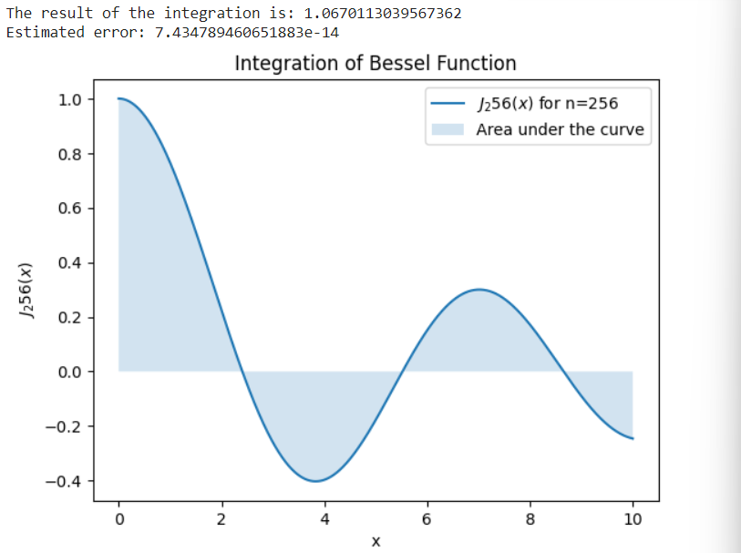



## 27. Double Integration

# Evaluate the expression: $\iint_{0 0}^{10 10}{e^{(-x^{2}-y^{2})}dx dy}$

**from math import \***

**import numpy as np**

**import pandas as pd**

**import matplotlib.pyplot as plt**

**from IPython.display import Image**

**from scipy import \***

**import scipy.linalg as la**

**from scipy.integrate import quad, dblquad, tplquad**

#Above this, is the block of libraries mostly used in scientific computing as told by professor. Though everything is not necessary for this code.

def integrand(x,y):

  return exp(-x**2-y**2)

x_lower=0; x_upper=10

y_lower=0; y_upper=10

val, abserr = dblquad(integrand, x_lower, x_upper, lambda x:y_lower, lambda x:y_upper)

#Here, the limits of integration for y are defined using lambda functions. Lambda functions are a way to create small, unnamed functions in Python. The general syntax for a lambda function is: lambda arguments: expression

print('value of Integration=',val,'absolute error=',abserr)

* **Value of Integration= 0.7853981633974476**

**Absolute Error= 1.3753098510194181e-08**

### 27.1 what is ‘pandas’?

**pandas** is a popular open-source data manipulation and analysis library for Python. It provides data structures like Series and DataFrame, *designed for efficient and intuitive handling and analysis of structured data*. The library is widely used in data science, machine learning, and analytics.

Here are some key features and capabilities of Pandas:

1. **DataFrame**: A two-dimensional, tabular data structure with labeled axes (rows and columns). It is similar to a spreadsheet or SQL table.
2. **Series**: A one-dimensional labeled array, similar to a column in a DataFrame or a single variable in statistics.
3. **Data Cleaning and Preparation**: Pandas provides a wide range of functions for cleaning and preparing data, including handling missing values, reshaping data, and transforming data.
4. **Data Analysis and Exploration**: It supports various operations for analyzing and exploring data, such as filtering, grouping, aggregation, merging, and sorting.
5. **Handling Time Series Data**: Pandas has functionality for working with time series data, making it suitable for applications in finance, economics, and other domains dealing with time-ordered data.
6. **Input/Output**: Pandas supports reading and writing data in various formats, including CSV, Excel, SQL databases, and more.

Here's a simple example of using Pandas to create a DataFrame:

import pandas as pd

# Creating a DataFrame

data = {'Name': ['John', 'Alice', 'Bob'],

        'Age': [28, 24, 22],

        'City': ['New York', 'Los Angeles', 'Chicago']}

df = pd.DataFrame(data)

# Displaying the DataFrame

print(df)

* 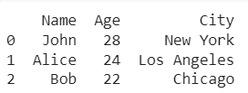

If you print without pandas this will look bad.

data = {'Name': ['John', 'Alice', 'Bob'],

        'Age': [28, 24, 22],

        'City': ['New York', 'Los Angeles', 'Chicago']}

print(data)

* 

### 27.2 from IPython.display import Image

**IPython**: IPython is an interactive command-line shell for Python. It provides features such as interactive computing, easy-to-use syntax, and enhanced introspection capabilities. IPython is often used in scientific computing, data analysis, and machine learning.

**IPython.display module**: This module within IPython provides tools for displaying various types of content in the IPython environment. It includes classes and functions for rendering multimedia content like images, audio, video, HTML, etc.

**Image class**: The **Image** class is part of the **IPython.display** module, and it is used to display images in the IPython environment. You can create an instance of the **Image** class and then display it using IPython's rich display capabilities.

from IPython.display import Image

# Get the path to the image file

image_path = '/home/sayak/DEsktop/flower.jpeg'

# Display the image

Image(image_path)

# Not working, some problem happened???!! Recheck!

### 27.3 Compare NumPy, SciPy and math

**NumPy:**

1. **Core Functionality**:
   * Provides support for large, multi-dimensional arrays and matrices (**numpy.ndarray**).
   * Essential for numerical operations and efficient array manipulation.
   * Fundamental building block for numerical computing in Python.
2. **Array Operations**:
   * Element-wise operations on arrays (addition, subtraction, multiplication, etc.).
   * Broadcasting: Operations between arrays of different shapes and sizes.
3. **Linear Algebra**:
   * Basic linear algebra operations (e.g., matrix multiplication, eigenvalue decomposition).
   * **numpy.linalg** module provides linear algebra functions.
4. **Random Number Generation**:
   * **numpy.random** module for generating random numbers and distributions.

**SciPy:**

1. **Extended Functionality**:
   * Extends NumPy with additional modules for scientific computing.
   * Covers a broader range of scientific and numerical algorithms.
2. **Integration and Differentiation**:
   * Numerical integration tools **scipy.integrate** (which contains **quad**, **dblquad**, **tplquad**).
   * Symbolic and numerical differentiation (**scipy.diff**).
3. **Optimization**:
   * Optimization algorithms for finding minima or roots of functions (**scipy.optimize**).
4. **Signal and Image Processing**:
   * Signal processing tools (**scipy.signal**).
   * Image processing functions (**scipy.ndimage**).
5. **Statistical Functions**:
   * Additional statistical functions beyond what NumPy provides (**scipy.stats**).
6. **Interpolation**:
   * Interpolation algorithms (**scipy.interpolate**).
7. **Special Functions**:
   * Mathematical special functions (**scipy.special**).
8. **Sparse Matrices**:
   * Sparse matrix support (**scipy.sparse**).

**math Library (Built-in):**

1. **Basic Mathematical Functions**:
   * Provides basic mathematical functions such as trigonometry, logarithms, exponentials, etc.
2. **Single-Value Operations**:
   * Operates on single values, not arrays or matrices.
3. **Pure Python Implementation**:
   * Part of the Python Standard Library and implemented in pure Python.
4. **Limited to Scalars**:
   * Designed for scalar operations and not optimized for array or matrix operations.

**Common Use Cases:**

* **NumPy**:
  + Essential for numerical and array-based computing.
  + Used in applications involving linear algebra, statistical analysis, and machine learning.
* **SciPy**:
  + Applied in scientific research and engineering for a wide range of numerical and computational tasks.
  + Used for solving complex mathematical problems in physics, chemistry, biology, and more.
* **math Library**:
  + Simple mathematical operations in a scalar context.
  + Suitable for basic math computations in non-array contexts.

**Relationship:**

* **Interdependence**:
  + SciPy builds on NumPy and often relies on NumPy arrays as its underlying data structure.
  + Both libraries are typically used together in scientific computing applications.
  + **math library** is a lightweight built-in library suitable for basic scalar mathematical operations.

In summary, NumPy provides fundamental array functionality and core numerical operations, while SciPy extends this functionality to cover a broader range of scientific computing tasks, including optimization, integration, signal processing, and more. The two libraries are designed to be used together to provide a comprehensive set of tools for numerical and scientific computing in Python.

## 28. Some more matrix operations

from scipy import *

import numpy as np

from math import *

import pandas as pd

import matplotlib.pyplot as plt

from IPython.display import Image

# Importing various libraries for numerical computing (**numpy** and **scipy**), basic mathematical operations (**math**), data manipulation (**pandas**), plotting (**matplotlib.pyplot**), and displaying images in IPython.

V1=np.array([1,2,4,5])

print('\n V1=',V1)

M1=np.array([[1,complex(2,0),3],[3,4,5],[0,9,2]])

print('\n M1=',M1)

# array **M1** with a mix of integers and complex numbers.

dd=M1[:,1]

print('\n dd=', dd)

#Extracting data: Slicing the second column of array **M1** and printing it. In Python and many programming languages, including NumPy, indexing typically starts from 0.

A=np.array([[6,1,1],[4,-2,5],[2,8,7]])

print('inverse=',np.linalg.inv(A)) #inverse

M1=np.random.random((3,3))

# you've created a 3x3 NumPy array named **M1** filled with random values between 0 and 1 using the **np.random.random** function. Each element in the array will be a random float in the half-open interval [0.0, 1.0).

ee=linalg.eigvals(M1)

print('\n eigenvalue=',ee)  #eigenvalue of random matrix

#from scipy.linalg import svd

#(this line is not necessary, because already everything imported from scipy)

M1=np.random.random((5,5))

U, s, VT = svd(M1)

print('U=',U)

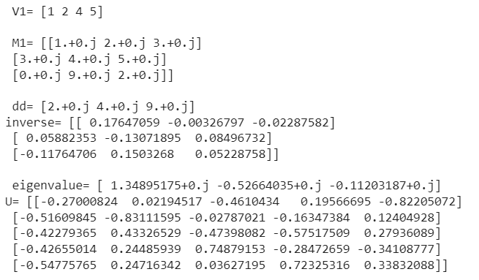

Note: Make sure that you have NumPy installed (**pip install numpy**) if you haven't already done so.

Note: The import statement **from scipy import \*** is generally discouraged as it can lead to namespace pollution. It's better to import specific functions or objects needed. Additionally, the **math** library is not extensively used in this code, as most operations are performed using **numpy** and **scipy** functions.

### 28.1 What is SVD?

The *Singular Value Decomposition (SVD)* of a matrix is a factorization of that matrix into three matrices. It also has some important applications in data science.

**Mathematics behind SVD:**

The SVD of  mxn matrix A is given by the formula  **A=U∑VT**

where:

* U:  *mxm* matrix of the orthonormal eigenvectors of AAT.
* ∑: diagonal matrix with r elements equal to the root of the positive eigenvalues of AAᵀ or Aᵀ A (both matrics have the same positive eigenvalues anyway).
* VT: transpose of a *nxn* matrix containing the orthonormal eigenvectors of ATA.

For more about SVD, visit <https://www.geeksforgeeks.org/singular-value-decomposition-svd/>

## 29. Data visualization-random curve and fill

import numpy as np

from matplotlib import pyplot as plt

ys = 200 + np.random.randn(100)

# Creating an array **ys** containing 100 random values drawn from a normal distribution with mean 200.

x = [x for x in range(len(ys))]

# The line is using a list comprehension to create an array **x** containing the indices of the array **ys**. So, after executing this line, **x** will be a list containing the indices **[0, 1, 2, ..., len(ys) - 1]**.

plt.plot(x, ys, '-')

plt.fill_between(x, ys, 195, where=(ys > 195), facecolor='g', alpha=0.6)

# Fills the area between the line plot and the y-axis where **ys** is greater than 195 with a green color ('g') and an alpha (transparency) of 0.6.

plt.title("Sample Visualization")

plt.show()

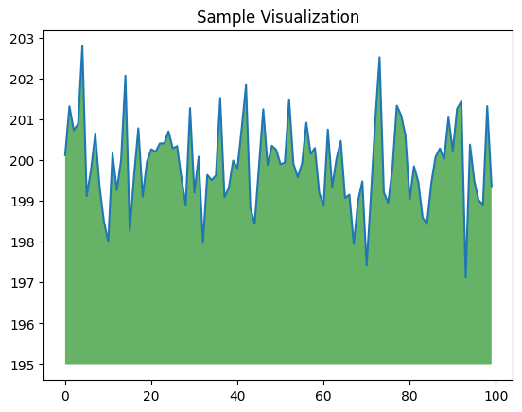

### 29.1 np.random.randn() & np.random.random()

what is the differences of randn and random?

Both np.random.randn(100) and np.random.random(100) generate random numbers, but they sample from different distributions:

1. **np.random.randn(100)**:

Generates an array of 100 random numbers sampled from a standard normal distribution (mean=0, standard deviation=1).

The numbers are drawn from a Gaussian (normal) distribution.

The range of values you can get from **np.random.randn** is theoretically unbounded. In practice, most of the values will be within a few standard deviations of the mean. Specifically, about 68% of the values will fall within one standard deviation of the mean, about 95% within two standard deviations, and about 99.7% within three standard deviations.

1. **np.random.random(100)**:

Generates an array of 100 random numbers sampled from a uniform distribution over the interval [0.0, 1.0).

The numbers are drawn from a uniform distribution, meaning they are equally likely to fall anywhere in the specified range.

## 30. Ex: Ball falling under gravity.

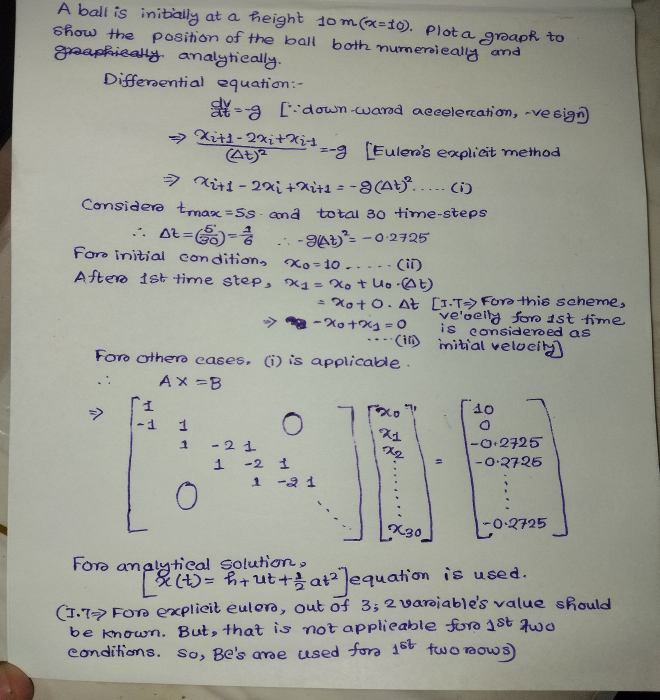

import numpy as np

import statistics

from scipy.linalg import solve

from matplotlib import pyplot as plt

t_max = 5;

n_max = 31;

#np = n_max;

h = 10;

g = -9.81;

v_ini=0;

t_domain = np.linspace(0, t_max, n_max)

res = [t_domain[i + 1] - t_domain[i] for i in range(len(t_domain)-1)]

#Time step sizes calculated as the difference between consecutive time values. ‘range’ is an one-dimensional array with total 30 delta_t values (1 less than t_domain)

dt = statistics.mean(res)

#Mean of the time step sizes. Though, here all-time steps are equal.

#rhs side

b=np.zeros((n_max,1))

b[0,0] = h

b[1,0] = v_ini * dt

for i in range(2, n_max):

  b[i,0] = g * dt**2

#lhs side

A=np.zeros((n_max,n_max))

A[0,0]=1;

A[1,0]=-1;

A[1,1]=1;

for i in range(2,n_max):

  A[i,i-2]=1;

  A[i,i-1]=-2;

  A[i,i]=1;

#Explanation of LHS and RHS are in handwritten part.

X = np.linalg.inv(A).dot(b)

#This gives numerical solution. Obviously, this is a column vector. You may also use, **X = np.linalg.solve(A, b).** This gives more stable solution and more precision.

#Also note: A.dot(B) gives matrix multiplication and A*B gives element wise multiplication.

X_A=h+0.5*g*(np.square(t_domain))+v_ini*t_domain

# This is analytical solution. It is calculated based on a mathematical expression rather than being the solution to a system of equations. So, X_A is a **1D array or row vector**. Note that, ‘t_domain’ is also an array.

print(X)

print(X_A)

plt.rcParams["figure.figsize"] = [5,3.8]

#sets the default figure size for Matplotlib plots. 5 inches in width and 3.8 inches in height.

plt.rcParams["figure.autolayout"] = True

#This line enables automatic layout adjustment for figures. When **figure.autolayout** is set to **True**, Matplotlib automatically adjusts the subplot parameters (e.g., margins, spacings) to fit the plot elements within the figure area. This can be useful to prevent issues where labels or titles get cut off.

plt.rcParams['axes.linewidth'] = 1

# sets the default linewidth for the axes (the border around the plot).

plt.rc('xtick',labelsize=14)

plt.rc('ytick',labelsize=14)

# sets the default font size for x and y-axis tick labels to 14 points.

h1, =plt.plot(t_domain,X_A,'r-',linewidth=2,label="analytical")

h2,=plt.plot(t_domain,X,'bo',linewidth=2,label="numerical")

# creates another line plot with x-values from **t_domain** and y-values from **X**. It uses blue circles ('bo') as markers for the data points and sets the line width to 2. The label is set to "numerical" for use in the legend**. See 30.3** for knowing the significances of ‘h1,’ and ‘h2,’..

plt.xlabel('t (s)',fontsize=20)

plt.ylabel('x (m)',fontsize=20)

plt.xlim(0,t_max)

plt.ylim(-150,1.5*h)

#These represents highest and lowest values of x and t axes.

plt.margins(x=0, y=0)

#zero margin. The plot will be stretched to fill the entire figure window. They provide a buffer between the plot and the edge of the figure. (I played with margins, but couldn’t notice any difference)!!.

first_legend = plt.legend(handles=[h1,h2], loc='lower right')

*#creates a legend for the plot and assigns it to the variable first_legend. The* ***plt.legend()*** *function takes two arguments****: handles*** *and* ***loc****. The* ***handles*** *argument is a list of line objects that will be included in the legend. The* ***loc*** *argument specifies the location of the legend (lower right corner) on the plot.*

plt.show()

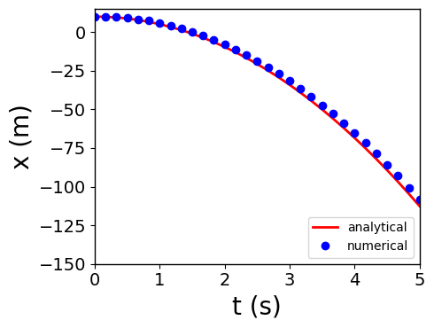

### (30.1) x=2+ np.array([[1, 2, 3]])+np.array([[2, 5, 9]]) what is the result?

Adds the scalar **2** to each element of the two arrays element-wise. The result will be:

array([[ 5, 9, 14]])

### (30.2) How to use column vectors and row vectors.

import numpy as np

# define a column vector

x = np.array([[1], [2], [3]])

# define a row vector

y = np.array([[1, 2, 3]])

# calculate the dot product of the two vectors

result = x.dot(y)

# print the result

print(result)

* **[[1 2 3]**

**[2 4 6]**

**[3 6 9]]**

### 30.3. The comma after h1 and h2 in the lines of code?

h1, =plt.plot(t_domain,X_A,'r-',linewidth=2,label="analytical") and h2, =plt.plot(t_domain,X,'bo',linewidth=2,label="numerical") is used?

This is to **unpack the returned value of the** plt.plot() **function**.

The plt.plot() function returns a **tuple** of line objects. In the given code, the first element of the tuple is assigned to the variable h1 and the second element of the tuple is assigned to the variable h2. The comma after h1 and h2 tells Python to ignore the other elements of the tuple.

This is a common technique used to unpack the returned value of a function that returns multiple values. It is a convenient way to assign the returned values to separate variables without having to use explicit indexing.

Here is an example of how to unpack the returned value of a function that returns multiple values:

Python

def my_function():

return 1, 2, 3

# unpack the returned value of the function

x, y, z = my_function()

# print the variables

print(x)

print(y)

print(z)

Output:

1

2

3

This example shows that unpacking the returned value of a function can be a convenient way to assign the returned values to separate variables.

In the given code, unpacking the returned value of the plt.plot() function is used to assign the first two line objects to the variables h1 and h2. This is done so that the line objects can be used to customize the plot, such as by changing the line color, line width, and line label.

Here is an example of how the variables h1 and h2 can be used to customize the plot:

Python

# change the line color of the analytical solution to red

h1.set_color('red')

# change the line width of the numerical solution to 2

h2.set_linewidth(2)

# change the line label of the numerical solution to 'numerical'

h2.set_label('numerical')

By unpacking the returned value of the plt.plot() function, we can easily customize the plot without having to explicitly index the line objects.

## 31. Spring-mass damper system.

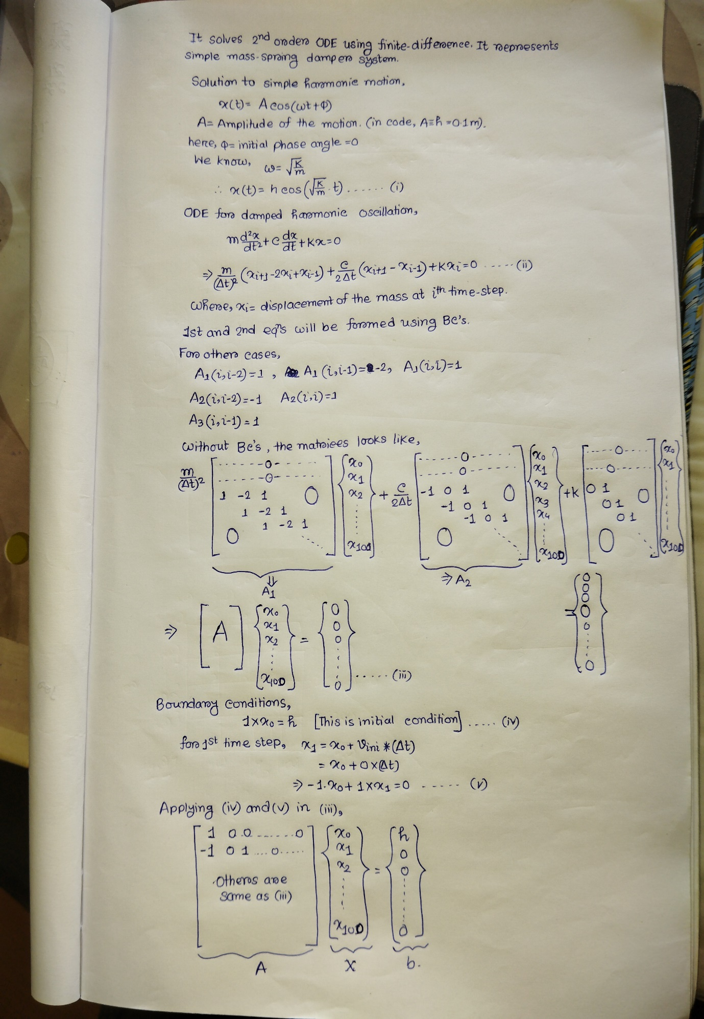

import numpy as np

import statistics

from scipy.linalg import solve

from matplotlib import pyplot as plt

t_max = 5

n_max = 101

m = 1

c = 0.1

k = 10

h = 0.1

v_ini = 0

#m: Mass of the system.

#c: Damping coefficient.

#k: Spring constant.

#h: Amplitude of the motion. (maximum displacement from equilibrium)

#v_ini: Initial velocity.

#t_max: Maximum time.

#n_max: Number of time steps.

t_domain = np.linspace(0, t_max, n_max)

res = [t_domain[i + 1] - t_domain[i] for i in range(len(t_domain) - 1)]

dt = statistics.mean(res)

#t_domain: An array of time values using np.linspace from 0 to t_max with n_max steps.

#res: array containing all time steps; and dt: Calculation of mean time step.

# LHS side

A1 = np.zeros((n_max, n_max))

A2 = np.zeros((n_max, n_max))

A3 = np.zeros((n_max, n_max))

for i in range(2, n_max):

    A1[i, i - 2] = 1

    A1[i, i - 1] = -2

    A1[i, i] = 1

    A2[i, i - 2] = -1

    A2[i, i] = 1

    A3[i, i - 1] = 1

# whole coefficient matrix

A = (m / (dt * dt)) * A1 + (c / (2 * dt)) * A2 + k * A3

print(np.shape(A))

#This represents the size of A. i.e, 101×101.

#Boundary conditions

A[0, 0] = 1

A[1, 0] = -1

A[1, 1] = 1

# RHS side

b = np.zeros((n_max, 1))

#Boundary conditions for RHS.

b[0, 0] = h

b[1, 0] = v_ini * dt

*#for All other equations, RHS is 0 (As per the ODE of damped oscillation)*

X = np.linalg.inv(A).dot(b)*#Numerical solutions.*

# Calculate analytical solution

X_A = h * np.cos(np.sqrt(k / m) * t_domain)

plt.rcParams["figure.figsize"] = [5, 3.8]

plt.rcParams["figure.autolayout"] = True

plt.rcParams['axes.linewidth'] = 1

plt.rc('xtick', labelsize=14)

plt.rc('ytick', labelsize=14)

h1, = plt.plot(t_domain, X_A, 'r-', linewidth=2, label="analytical")

h2, = plt.plot(t_domain, X, 'bo-', linewidth=2, label="numerical")

plt.xlabel('t (s)', fontsize=20)

plt.ylabel('x (mm)', fontsize=20)

plt.xlim(0, t_max)

plt.ylim(-1.1 * h, 1.1 * h)

plt.margins(x=0, y=0)

# Combine legends

first_legend = plt.legend(handles=[h1, h2], loc='lower right')

plt.show()

#For detailed explanation on plotting, see question no 30.

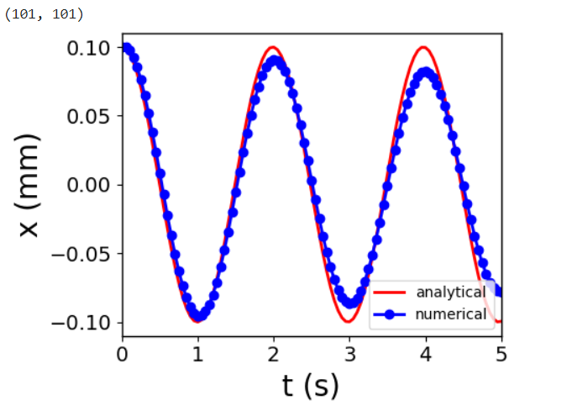

## 32. Ex: Spring-mass-damper with forcing

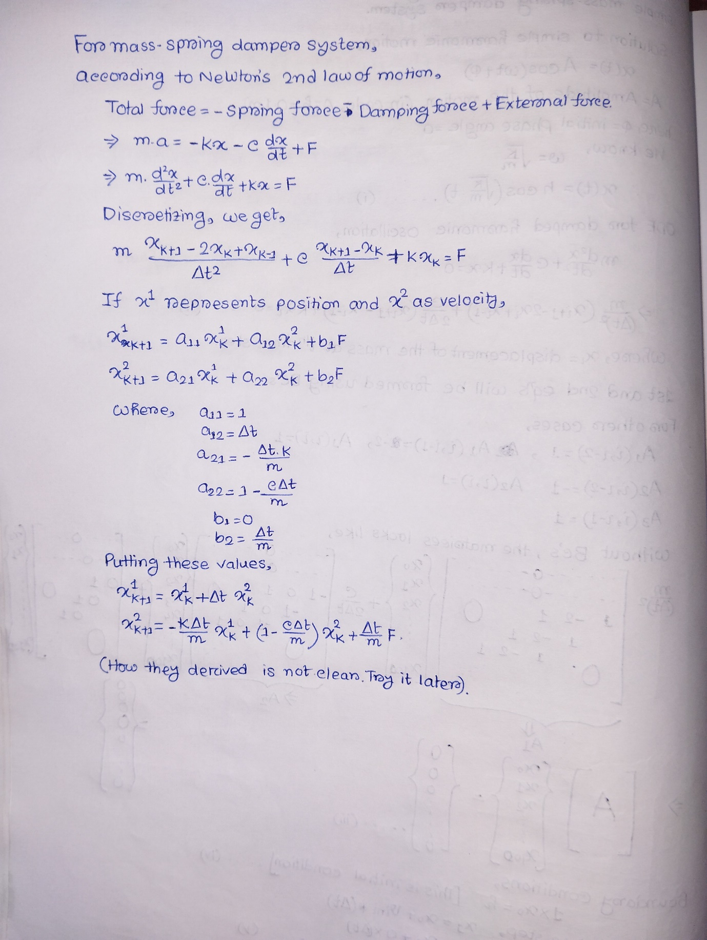

# Simulation of Mass-Spring-Damper System

import numpy as np

import matplotlib.pyplot as plt

# Model Parameters

c = 4 # Damping constant

k = 2 # Stiffness of the spring

m = 20 # Mass

F = 5 # Force

# Simulation Parameters

Ts = 0.1

Tstart = 0

Tstop = 60

N = int((Tstop-Tstart)/Ts) # Simulation length

x1 = np.zeros(N+2)

x2 = np.zeros(N+2)

x1[0] = 0 # Initial Position

x2[0] = 0 # Initial Speed

**a11 = 1**

**a12 = Ts**

**a21 = -(Ts*k)/m**

**a22 = 1 - (Ts*c)/m**

**b1 = 0**

**b2 = Ts/m**

#!!???

# Simulation

for k in range(N+1):

  x1[k+1] = a11 * x1[k] + a12 * x2[k] + b1 * F

  x2[k+1] = a21 * x1[k] + a22 * x2[k] + b2 * F

# Plot the Simulation Results

t = np.arange(Tstart,Tstop+2*Ts,Ts)

# creates a NumPy **array containing the time steps** for the simulation. 2*Ts is added to ensure that the simulation runs for at least two time steps beyond the desired stop time. Some numerical integration methods, such as the Euler method, require two-time steps to initialize. This is because the Euler method uses a forward difference approximation for the time derivative, which requires two-time steps to calculate. Runge-Kutta method, do not require two time steps to initialize. However, it is still good practice to run the simulation for at least two-time steps beyond the desired stop time. This is because the Runge-Kutta method can produce inaccurate results if the simulation is stopped too early

#plt.plot(t, x1, t, x2)

plt.plot(t,x1)

plt.plot(t,x2)

plt.title('Simulation of Mass-Spring-Damper System')

plt.xlabel('t [s]')

plt.ylabel('x(t)')

plt.grid()

plt.legend(["x1", "x2"])

plt.show()

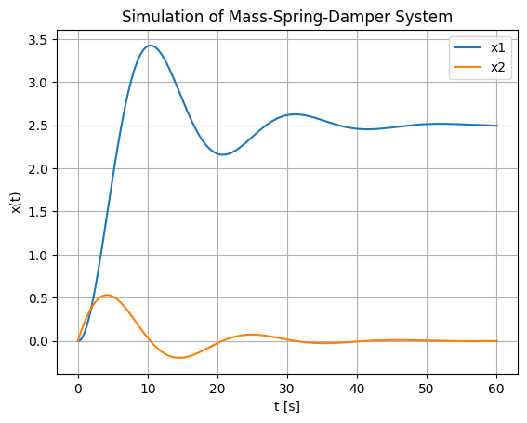

## 33. Spring-mass-damper with direct integration

import numpy as np

from scipy.integrate import odeint

import matplotlib.pyplot as plt

tstart=0.0

tend=60.0

incre=0.1

t=np.arange(tstart,tend+1,incre)

*#* ***np.arange*** *function is used to create an array* ***t*** *with time values from* ***tstart*** *to* ***tend*** *with a step size of* ***incre****.1 more time step was taken in simulation for better accuracy.*

# initial condition

a=0

b=0.1

*# a is the initial position, and b is the initial velocity.*

x_init=[a,b]

def smdiff(x,t):

  c=4

  k=2

  m=20

  w=2 #frequency in radian per second.

  F=5*np.sin(w*t)

  dx1dt=x[1]

# Assigns the velocity (**x[1]**) to the derivative of position (dx1​/dt).

  dx2dt=(F-c*x[1]-k*x[0])/m

# Calculates the acceleration or derivative of velocity (dx2​/dt) based on the mass-spring-damper equation. It considers the external force (F), damping term (c⋅x[1]), and spring term (k⋅x[0]). The result is divided by the mass (m) to get acceleration.

  dxdt =[dx1dt,dx2dt]

# Combines the derivatives into a list, representing the rate of change of position and velocity.

  return dxdt

***#In Above, a function named smdiff is just defined which returns dxdt.***

x=odeint(smdiff,x_init,t)

***#odeint*** *is used to numerically solve the ODEs defined by* ***smdiff****. It takes the function* ***smdiff****, initial conditions* ***x_init****, and time values* ***t*** *as inputs and returns an array* ***x*** *representing the system's state variables over time. X has two columns here.having position and velocity over time.*

print('x=',x)

x1=x[:,0]

x2=x[:,1]

*#x1 and x2 takes values of position and velocity from column1 and column 2 of ‘x’ matrix respectively.*

plt.plot(t,x1)

plt.plot(t,x2)

plt.xlabel('t')

plt.ylabel('..')

plt.grid()

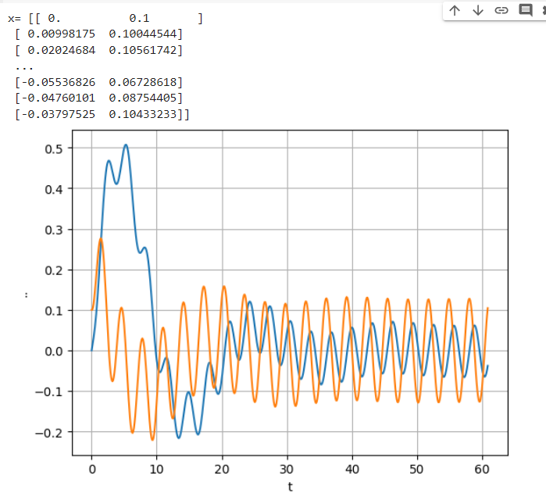plt.show()

=>

### 33.1 More about odeint function.

The **odeint** function in SciPy's **integrate** module is used for numerical integration of a system of ordinary differential equations (ODEs). The function signature for **odeint** is as follows:

Here's an explanation of the main arguments:

scipy.integrate.odeint(func, y0, t, args=(), ...)

**func**: The system of ordinary differential equations (ODEs) to be solved. It should take two arguments: the current state **y** and the current time **t**, and return the derivatives of the state variables.

**y0**: The initial conditions for the system. It represents the values of the state variables at the starting time **t[0]**. It can be a list or array.

**t**: The time points at which the solution should be computed. It can be an array of time values.

**args**: (Optional) Additional arguments to be passed to the ODE function (**func**). If your ODE function requires additional parameters beyond **y** and **t**, you can pass them through **args** as a tuple.

from scipy.integrate import odeint

import numpy as np

def myODE(y, t, a, b):

    # Example ODE function

    dydt = a * y[0] - b * y[1]

    dzdt = b * y[0] + a * y[1]

    return [dydt, dzdt]

# Initial conditions

y0 = [1.0, 0.0]

# Time points

t = np.linspace(0,5,10)

# Additional parameters

a = 2.0

b = 1.0

*#I think, if you provided the values of a and b within the function definition portion, you should not provide additional arguments in ‘odeint’.*

# Solve the ODEs

result = odeint(myODE, y0, t, args=(a, b))

print(result)

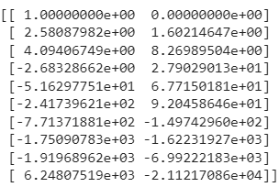

## 34. Laplace equation solution

# Simple Numerical Laplace Equation Solution using Finite Difference Method

import numpy as np

import matplotlib.pyplot as plt

# Set maximum iteration

maxIter = 500

# Set Dimension and delta

lenX = lenY = 20

#we set it rectangular. 20 points are taken in x and y directions.

delta = 1

# Grid spacing.

# Boundary condition

Ttop = 100

Tbottom = 0

Tleft = 0

Tright = 30

# Initial guess of interior grid

Tguess = 30

# Set array size and set the interior value with Tguess

T = np.empty((lenX, lenY))

T.fill(Tguess)

# Create an array **T** of size **(lenX, lenY)** and fill it with the initial guess value (**Tguess**).

# Set Boundary condition

T[(lenY-1):, :] = Ttop

T[:1, :] = Tbottom

T[:, (lenX-1):] = Tright

T[:, :1] = Tleft

#These things are explained in 34.2.

# Iteration (We assume that the iteration is convergence in maxIter = 500)

print("Please wait for a moment")

for iteration in range(0, maxIter):

#The for loop iterates over the iteration numbers. The range() function creates a list of integers from 0 to maxIter-1.

    for i in range(1, lenX-1, delta):

        for j in range(1, lenY-1, delta):

#The inner for loop iterates over the grid points. The range() function creates a list of integers from 1 to lenX-2 and from 1 to lenY-2(because range function excludes the last value). This ensures that the loop does not iterate over the boundary points.

            T[i, j] = 0.25 * (T[i+1][j] + T[i-1][j] + T[i][j+1] + T[i][j-1])

#This line of code updates the value of the scalar field at the grid point (i, j). The new value is equal to the average of the values at the four adjacent grid points.

print("Iteration finished")

# Set colour interpolation and colour map

colorinterpolation = 50

#The contour plot will have 50 different color levels.  A higher value of colorinterpolation will result in a smoother contour plot, but it will also take longer to render.

colourMap = plt.cm.jet

#The Matplotlib library provides a variety of built-in color maps. you can try: colourMap = plt.cm.coolwarm also.

# Set meshgrid

X, Y = np.meshgrid(np.arange(0, lenX), np.arange(0, lenY))

# to create a 2D grid of coordinates based on the 1D arrays generated by **np.arange**. See 34.3 for explanation.

# Configure the contour

plt.title("Contour of Temperature")

plt.contourf(X, Y, T, colorinterpolation, cmap=colourMap)

# This line generates a filled contour plot with colours representing different temperature levels. See 34.4 for explanation.

# Set Colorbar

plt.colorbar()

# Show the result in the plot window

plt.show()

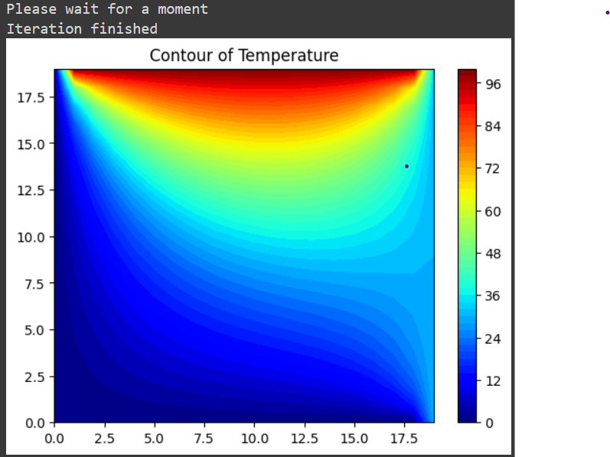

### 34.1 T = np.empty((lenX, lenY)). Can we place ‘zeros’ in place of ‘empty’.

**np.zeros((lenX, lenY))**: This creates a 2D array of shape **(lenX, lenY)** filled with zeros.

**np.empty((lenX, lenY))**: This creates a 2D array of shape **(lenX, lenY)** without initializing the elements. The elements of the array may contain any values.

For this specific application, the use of **np.zeros** followed by **T.fill(Tguess)** is preferable for clarity and to ensure a well-defined initial state for the **T** array.

### 34.2 How boundary conditions are assigned in 2D grid.

import numpy as np

lenX=5

lenY=5

T = np.zeros((lenX, lenY))

T[(lenY-1):, :] = 1   #Ttop

#“(lenY-1):” means: from row index =4 to all after that; means only 5th row for this case.

T[:1, :] = 2          #Tbottom

# “:1” means: from starting row to the row having row index=1 (i.e 2nd row) but **excludes that**. That means , this BC is applicable for only 1st row and all columns.

T[:, (lenX-1):] =3    #Tright

T[:, :1] = 4          #Tleft

#The boundary conditions mentioned later overwrites the previous ones. So, “Tleft” and “Tright” takes corner values.

print(T)

**[[4. 2. 2. 2. 3.]**

**[4. 0. 0. 0. 3.]**

**[4. 0. 0. 0. 3.]**

**[4. 0. 0. 0. 3.]**

**[4. 1. 1. 1. 3.]]**

**Note that:** Bottom boundary conditions takes the top row of the matrix. So, value entries to the matrix follows the below mentioned pattern. (Picture is taken from Computational hydraulics notes):

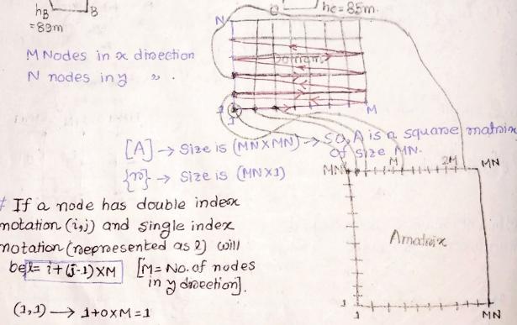

### 34.3. X, Y = np.meshgrid(np.arange(0, lenX), np.arange(0, lenY))

This line is using NumPy's **meshgrid** function to create a 2D grid of coordinates based on the 1D arrays generated by **np.arange**. Let's go step by step:

**np.arange(0, lenX) and np.arange(0, lenY):**

* + These create 1D arrays of evenly spaced values from 0 to **lenX-1** and from 0 to **lenY-1**, respectively. These arrays represent the x and y coordinates along the respective axes of your grid.

**np.meshgrid(...):**

* + This function takes multiple 1D arrays and produces 2D arrays representing a grid of coordinates.
  + **np.meshgrid(np.arange(0, lenX), np.arange(0, lenY))** returns two 2D arrays, **X** and **Y**.
  + **X** represents the x-coordinates for each point in the grid, and **Y** represents the y-coordinates.

**Here, one example to elaborate this:**

import numpy as np

A=np.arange(0, 5)

B=(np.arange(0, 5), np.arange(0, 5))

X, Y = np.meshgrid(np.arange(0, 5), np.arange(0, 5))

print('A=',A)

print('B=',B)

print('X=',X)

print('Y=',Y)

* 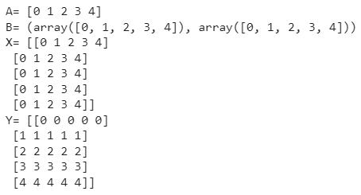

### 34.4. plt.contourf(X, Y, T, colorinterpolation, cmap=colourMap)

X and Y: These are the 2D arrays representing the coordinates of the grid. They were created using np.meshgrid and define the positions where the temperature values are sampled.

T: This is the 2D array representing the temperature values at each point on the grid.

colorinterpolation: We have assigned 50 distinct colors will be used to represent different temperature levels.

cmap=colourMap: This parameter specifies the colormap to be used for coloring the contours (previously defined as plt.cm.jet).

## 35. Class project: Temperature distribution over plate.

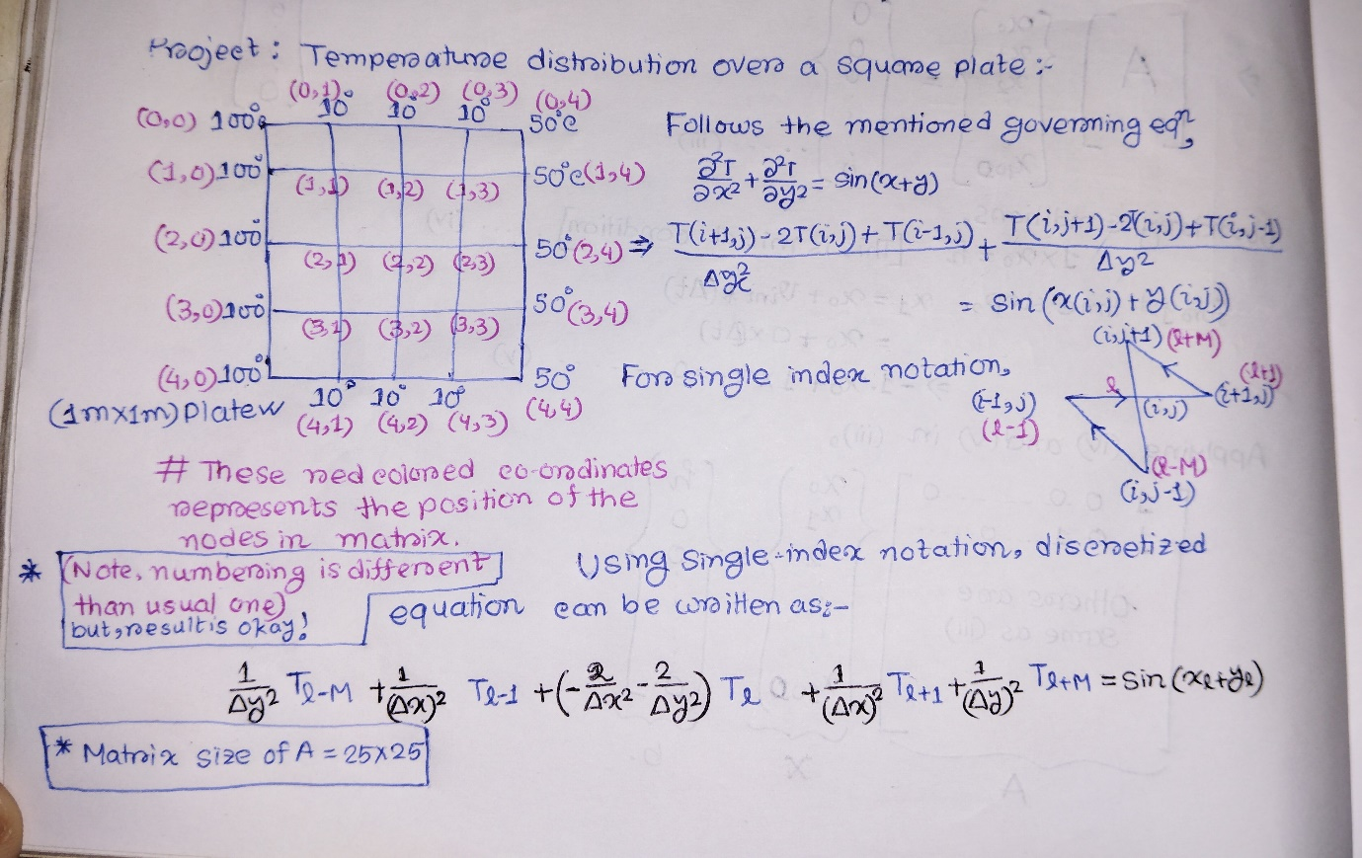

from scipy import *

import numpy as np

from math import *

import pandas as pd

import matplotlib.pyplot as plt

mnode = 5

nnode = 5

Lx = 1

Ly = 1

delta_x = Lx / (mnode - 1)

delta_y = Ly / (nnode - 1)

x = np.linspace(0, 1, mnode)

y = np.linspace(0, -1, nnode)

#print(y)

alphax = 1 / (delta_x) ** 2

#print(alphax)

alphay = 1 / (delta_y) ** 2

mnnode = mnode * nnode

A = np.zeros((mnnode, mnnode))

#print(A)

r = np.zeros((mnnode, 1))

#print(r)

for j in range(0, nnode):

    for i in range(0, mnode):

        l = i + j * mnode

        if i == 0 and j in range(1, mnode-1):

            A[l, l] = 1

            r[l] = 10

        elif i in range(1, nnode-1) and j == 0:

            A[l, l] = 1

            r[l] = 100

        elif i in range(1, nnode-1) and j == (mnode - 1):

            A[l, l] = 1

            r[l] = 50

        elif i == (nnode - 1) and j in range(1, mnode - 1):

            A[l, l] = 1

            r[l] = 10

        elif i == 0 and j == 0:

            A[l, l] = 1

            r[l] = 100

        elif i == 0 and j == mnode - 1:

            A[l, l] = 1

            r[l] = 50

        elif i == nnode - 1 and j == 0:

            A[l, l] = 1

            r[l] = 100

        elif i == nnode - 1 and j == mnode - 1:

            A[l, l] = 1

            r[l] = 50

        else:

            A[l, l - mnode] = alphay

            A[l, l - 1] = alphax

            A[l, l] = -2 * (alphax + alphay)

            A[l, l + 1] = alphax

            A[l, l + mnode] = alphay

            r[l] = sin(x[i] + y[j])

T = np.linalg.solve(A, r)

#print(T)

Temp=np.zeros((mnode,nnode))

for j in range(0,nnode):

  for i in range(0,mnode):

    Temp[i,j]=T[i+j*nnode]

print('Temp=',Temp)

#’T’ is an one dimensional array where temperature values were arranged according to single index notation. Then in ‘Temp’ matrix, I arranged those values as per grid point locations.

plt.contourf(x,y,Temp,cmap=plt.cm.jet)

# The function plt.contourf(x, y, Temp, cmap=plt.cm.jet) in Python's Matplotlib library plots a filled contour plot of the scalar field Temp at the coordinates x and y.

# The cmap keyword argument specifies the color map that will be used to represent the different levels of the scalar field in the contour plot. The Matplotlib library provides a variety of built-in color maps, including **plt.cm.jet,** **plt.cm.coolwarm**, and **plt.cm.rainbow.** The plt.cm.jet color map is a rainbow color map, with the colors ranging from blue to red. The plt.cm.gray color map is a grayscale color map, with the colors ranging from black to white.

plt.colorbar()

plt.xlabel('X')

plt.ylabel('Y')

plt.title('Spatial Distribution of Temperature in Square Plate')

plt.show()

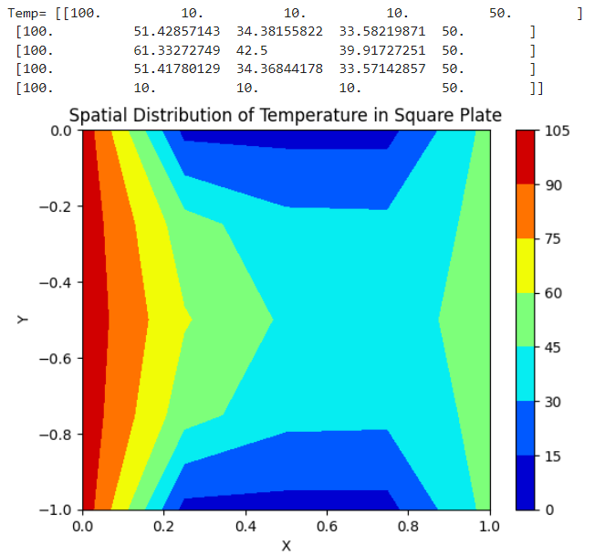

## 36. lists, loops, string manipulation, and basic Python syntax.

from scipy import *

import numpy as np

from math import *

import pandas as pd

import matplotlib.pyplot as plt

from IPython.display import Image

friends=['joseph','gleen', 'sally']

print(friends)

output>> ['joseph', 'gleen', 'sally']

x=2

x='hello'

x=4

print(x)

# Reassigns the variable x multiple times and prints its final value., which is 4.

Output>> 4

print([1,24,76])

Output>> [1, 24, 76]

print(['red','yellow','blue'])

Output>> ['red', 'yellow', 'blue']

print([1,[5,6],7])

Output>> [1, [5, 6], 7]

print(['red',24,98.6])

Output>> ['red', 24, 98.6]

print([])

Output>> []

for i in [5,4,3,2,1]:

  print (i)

print ('Blastoff!')

Output>>

5

4

3

2

1

Blastoff!

friends=['joseph','gleen', 'sally']

for friend in friends:

  print ('Happy New Year', friend)

print ('done')

# Prints a New Year's greeting for each friend in the list.

Output>>

Happy New Year joseph

Happy New Year gleen

Happy New Year sally

done

friends=['joseph' , 'gleen', 'sally']

print(friends[1])

# prints the second element of the list friends to the console. Index in python starts from 0.

Output>> gleen

fruit='Banana'

fruit[0]='b'

# it tries to reassign the first character of the string fruit to the character 'b'. This is not possible, however, because strings are immutable in Python.

Output>>

TypeError: 'str' object does not support item assignment

fruit='Banana'

x=fruit.lower()

print (x)

#The code converts the string fruit to lowercase using the lower() method and then assigns the new string to the variable x. string ‘fruit’ is not changed; because it is immutable.

Output>> banana

lotto=[2,14,26,41,63]

print (lotto)

lotto[2]=28

# String are immutable in python, but lists are not. See 36.1 for details.

print (lotto)

Output>>

[2, 14, 26, 41, 63]

[2, 14, 28, 41, 63]

name=['joseph','gleen', 'sally']

name[1]='raja'

name[2]=90

print(name)

Output>> ['joseph', 'raja', 90]

greet='hello bob'

print (len(greet))

x=[1,2,44.3,'joe']

print (len(x))

#’len’ function returns the number of characters in the string and the number of elements in list.

Output>>

9

4

print(range(4))

print (list(range(4)))

# First line prints a range object, while the second line prints a list containing the values of the range object. A range object is a sequence of numbers. It is not a list, but it can be converted to a list using the list() function.

# It is better to use a list than a range object because lists are more efficient for accessing elements than range objects. But, if you need to iterate over the sequence in a for loop, then you must use a range object.

Output>>

range(0, 4)

[0, 1, 2, 3]

**#Use of ‘range’ in for loop:**

name=['joseph','gleen', 'sally']

print(len(name))

for i in range (len(name)):

  friend=name[i]

  print('happy new year:', friend)

Output >>

3

happy new year: joseph

happy new year: gleen

happy new year: sally

### #Addition with and without Numpy.

**#Without numpy**

a=[1,2,3]

b=[4,5,6]

c=a+b

d=[a[1],a[2]]

e=a+d

print('c=',c)

print('d=',d)

print('e=',e)

# In python, the **+** operator for lists results in a new list that contains all the elements from the first list followed by all the elements from the second list. it doesn't perform element-wise addition.

Output >>

c= [1, 2, 3, 4, 5, 6]

d= [2, 3]

e= [1, 2, 3, 2, 3]

If you want to perform element-wise addition, you should consider using NumPy arrays.

**#With NumPy:**

import numpy as np

a = np.array([1, 2, 3])

b = np.array([4, 5, 6])

c = a + b

print('c=',c)

Output >> c= [5 7 9]

t=[9,41,12,3,74,15,5]

#Remember, array indexing in python starts from 0, not 1.

print(t[1:3])

#Prints from element_1 (including) to element_3 (excluding)[means up to element 2].

print(t[:4])

# Prints from element_0 to element_3

print(t[3:])

# Prints from element_3 to last element.

print(t[:])

#Prints all element.

print(t[::2]) #alternate terms

print(t[::3]) #every third terms

Output >>

[41, 12]

[9, 41, 12, 3]

[3, 74, 15, 5]

[9, 41, 12, 3, 74, 15, 5]

[9, 12, 74, 5]

[9, 3, 5]

x=[1,2,3]

print(type(x))

dir(x)

#**dir(x)** function to get a list of valid attributes and methods for the list object **x**. This will provide you with a list of names containing the attributes and methods supported by lists.

Output >>

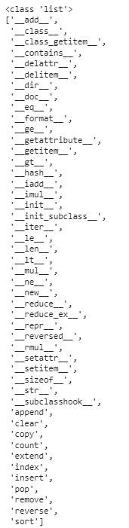

stuff=list()

#This creates an empty list named **stuff**.

stuff.append('book')

stuff.append('99')

stuff.append('cookie')

print(stuff)

#This appends three elements ('book', '99', and 'cookie') to the list and prints the contents of the list after the append operations.

stuff[2]=' '

print(stuff)

#This line modifies the element at index 2 (the third element, 'cookie') and replaces it with a space (' ') and prints the updated list.

Output >>

['book', '99', 'cookie']

['book', '99', ' ']

some =[1,33,23,56]

print(9 in some)

#This checks if the value 9 is present in the list **some**. The output will be **False** because 9 is not in the list.

print(9 not in some)

#This checks if the value 9 is not present in the list **some**.

some.append(2)

#This appends the value 2 to the end of the list **some**.

print(some)

Output >>

False

True

[1, 33, 23, 56, 2]

friends=['joseph','gleen', 'sally']

friends.sort()

print (friends)

#sorts the list friends in alphabetical order and then prints it.

Output >> ['gleen', 'joseph', 'sally']

numbers=[1, 89, 3, 12, 234]

numbers.sort()

numbers.remove(12)

print(numbers)

#This sorts the list **numbers** in ascending order, then removes the element **12** from the list and prints the updated list.

print(len(numbers)) # length of the list ‘numbers’

print(max(numbers)) #the maximum value in the list ‘numbers’

print (min(numbers)) #the minimum value in the list ‘numbers’

print (sum(numbers)) #sum of all elements in the list ‘numbers’

print (sum(numbers)/len(numbers)) #average of all elements.

Output >>

[1, 3, 89, 234]

4

234

1

327

81.75

abc='with three words'

stuff=abc.split()

print(stuff)

#The **split()** method is then applied to this string, which splits the string into a list of words based on whitespace (spaces and tabs are the default delimiters). The resulting list is assigned to the variable **stuff**.

print(len(stuff))

print(stuff[0])

Output >>

['with', 'three', 'words']

3

With

line='A lot of       spaces'

etc=line.split()

*# spaces and tabs are the default delimiters for ‘split’. So, no effect of lot of spaces between words.*

print(etc)

Output >> ['A', 'lot', 'of', 'spaces']

New='with;three;words'

*# Semicolon is not a default delimiter for split method. So, everything in ‘New’ string is considered as one element.*

thing=New.split()

print(thing)

print(len(thing))

Output >>

['with;three;words']

1

### 36.1. String are immutable in python, but lists are not?

Yes, that's correct. In Python, strings are immutable, meaning you cannot change their content once they are created. If you want to modify a string, you need to create a new string. This is why the line **# fruit[0] = 'b'** in your script would raise an error.

On the other hand, lists in Python are mutable. You can modify their elements by assigning new values to specific indices. In your script, the line **lotto[2] = 28** is an example of modifying a list; it changes the value of the element at index 2 to 28.

## 37.Data handling with Pandas and Visualisation with Matplotlib

## 38. Pandas

Brief Overview of the Pandas Library

Pandas is a fast, powerful, and flexible open-source data analysis and data manipulation Python library. Built on top of the Python programming language, it provides data structures like Series and DataFrames for handling and analyzing structured data.

Data Structures:

* **Series**: 1D labeled array capable of holding any data type.
* **DataFrame**: 2D labeled data structure with columns that can be of different types.
* **Functionalities**: It offers various functionalities to perform tasks ranging from data cleaning, transformation, and visualization to more complex operations like aggregation and reshaping.

Relevance in Data Analysis

* **Data Wrangling**: Pandas makes it straightforward to clean and process messy and raw data into a more suitable and clean form.
* **Exploratory Data Analysis (EDA)**: With functions that help to inspect data, compute summary statistics, and visualize distributions, Pandas is a go-to tool for preliminary data investigation.

Why Pandas?

Importance in Data Manipulation and Analysis

* **Ease of Use**: The library’s syntax is straightforward, which makes it easy for beginners to get started.
* **Flexibility**: Can handle a variety of data formats (like CSV, Excel, SQL databases, and even HDF5), and its DataFrame structure allows you to transform data quickly.
* **Performance**: Built on top of C libraries like NumPy, it’s fast and efficient for data manipulation.
* **Community Support**: As one of the most popular data science libraries, it has a strong community and a plethora of tutorials, making it easier to find help and resources.

Ease of Use

* **Intuitive Syntax**: The Pandas API is designed to be intuitive and easy, making it accessible for new users and comprehensive for experienced ones.
* **Comprehensive Documentation**: An array of examples and community-contributed tutorials mean that most problems you encounter have already been solved and documented.

By integrating seamlessly with other data science libraries like Matplotlib for plotting and Scikit-learn for machine learning, Pandas enables end-to-end data analysis right within Python, making it an essential tool for anyone engaged in data science or data analysis.

**import pandas and numpy**

It is convention import these libraries in the following way.

import pandas as pd

import numpy as np

import matplotlib.pyplot as plt

Make sure you have Pandas installed in your Python environment. You can install it using pip if it's not already installed: pip install pandas

## 39. Basic Data Structures in Pandas: Series

A Pandas Series is essentially a one-dimensional array that can hold any data type. It comes with an index, which allows for both positional and label-based indexing.

Syntax: pd.Series(data)

Creation of a Pandas Series: You can create a Series from a list, dictionary, or NumPy array.

### 39.1 Panda series from a List

import pandas as pd

data = [1, 2, 3, 4]

ds = pd.Series(data)

ds

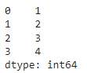

# "dtype" stands for "data type," indicating the type of data the Series holds. "int64" is the specific data type, which represents 64-bit integers.

### 39.2 Panda series from a Dictionary

import pandas as pd

data = {'a': 1, 'b': 2, 'c': 3}

print("The data dictionary is", data)

s = pd.Series(data)

print(s)

#This code creates a Pandas Series **s** from the dictionary **data**. In this Series, the keys from the dictionary become the index of the Series, and the values in the dictionary become the data in the Series. The default data type is "int64" because all values in this Series are integers.

* The data dictionary is {'a': 1, 'b': 2, 'c': 3}

a 1

b 2

c 3

dtype: int64

### 39.3 Panda series from a NumPy Array

import pandas as pd

import numpy as np

data = np.array([1, 2, 3])

print("The data as a numpy array is:", data)

s = pd.Series(data)

print(s)

# This code first creates a NumPy array **data** with elements [1, 2, 3] and then converts it into a Pandas Series **s**.

* **The data as a numpy array is: [1 2 3]**

**0 1**

**1 2**

**2 3**

**dtype: int64**

## 40. Difference between NumPy arrays and Pandas Series

If you are working with homogeneous numerical data and need performance (faster numerical computations), NumPy is a better choice. If you have labelled or heterogeneous data and need powerful data manipulation tools, Pandas Series and Data Frames are more suitable. In many cases, both NumPy and Pandas are used together to take advantage of their respective strengths.

**Advantages of NumPy Arrays:**

**1. Homogeneous Data**: NumPy arrays are great for numerical data with a single data type, which allows for efficient operations.

1. import numpy as np
2. # Example of a NumPy array
3. data = np.array([1, 2, 3])
4. data

* **array([1, 2, 3])**

**2.Performance**: NumPy is optimized for numerical operations. In the following example, you'll likely see that NumPy is faster for numerical operations. Here's a simple performance comparison:

import numpy as np

import pandas as pd

import timeit

# This library is for measuring execution time.

**# Using NumPy array**

numpy_data = np.arange(1, 10001)

# It creates a NumPy array **numpy_data** containing values from 1 to 10000 using **np.arange(1, 10001)**.

def numpy_sum():

    return np.sum(numpy_data)

# It defines a function **numpy_sum()** that calculates the sum of all elements in the **numpy_data** using **np.sum()**.

numpy_time = timeit.timeit(numpy_sum, number=10000)

# It uses the **timeit** module to measure the execution time of the **numpy_sum** function by calling it 10,000 times. The result is stored in the **numpy_time** variable.

**# Using Pandas Series**

pandas_data = pd.Series(range(1, 10001))

def pandas_sum():

    return pandas_data.sum()

pandas_time = timeit.timeit(pandas_sum, number=10000)

print("sum with numpy=",numpy_sum())

print("sum with panda=",pandas_sum())

print("NumPy time:", numpy_time)

print("Pandas time:", pandas_time)

**sum with numpy= 50005000**

**sum with panda= 50005000**

**NumPy time: 0.07156486299982134**

**Pandas time: 0.3480711040001552**

**Disadvantages of NumPy Arrays:**

**Homogeneity Requirement**: NumPy arrays require homogeneous data. If you need to store different data types or have labeled data, NumPy is not well-suited.

**Advantages of Pandas Series:**

**1. Heterogeneous Data**: Pandas Series can store data with different data types in a single structure, which is useful for handling real-world data.

import pandas as pd

# Example of a Pandas Series with heterogeneous data

data = pd.Series([1, 'two', 3.0])

# Here, elements are integer, string and float respectively. Since the data types are different, Pandas has inferred the data type of the Series as **object.**

print(data)

* 0 1

1 two

2 3.0

dtype: object

If you want to ensure that all elements have the same data type in your Series, you can explicitly specify the data type when creating the Series. For example:

import pandas as pd

data = pd.Series([1, 'two', 3.0], dtype='string')

print(data)

* **0 1**
* **1 two**
* **2 3.0**
* **dtype: string**

**2.Labelled Indexing**: Pandas Series provide labelled indices for easier and more intuitive data access.

import pandas as pd

# Creating a Series with labeled index

data = pd.Series([10, 20, 30], index=['A', 'B', 'C'])

print(data['B'])  # Accessing data by label

* **20**

**3.Additional Data Manipulation Features**: Pandas Series offer numerous data manipulation functions, like filtering, grouping, and handling missing data.

import pandas as pd

data = pd.Series([10, 20, None, 30])

print(data.dropna())

#The output of **data.dropna()** will be a new Series with the missing value (None) removed.

print(data)

* **0 10.0**

**1 20.0**

**3 30.0**

**dtype: float64**

**0 10.0**

**1 20.0**

**2 NaN**

**3 30.0**

**dtype: float64**

As you can see, the missing value has been removed from the Series, and the resulting Series has a data type of **float64** because Pandas automatically converts the integers to floats to accommodate the missing value (**NaN**).

To replace missing values with 0, we use fillna().

import pandas as pd

data = pd.Series([10, 20, None, 30])

data.fillna(0, inplace=True)

# Fills missing values with 0.

print(data)

* **0 10.0**

**1 20.0**

**2 0.0**

**3 30.0**

**dtype: float64**

**Disadvantages of Pandas Series:**

1. **Performance**: Due to their flexibility and heterogeneity, Pandas Series may not be as efficient as NumPy arrays for numerical operations, especially with large datasets.
2. **Overhead**: Pandas Series have additional overhead due to their data structure and indexing, which can lead to increased memory usage.

## 41. DataFrame

**Definition**: A Pandas DataFrame is a 2D table with labelled axes (rows and columns). Each column can have its own data type, and you can perform operations much like you would in a SQL table or an Excel spreadsheet.

**Syntax**:

pd.DataFrame(data, columns=columns, index=index)

**Creation of a Pandas DataFrame** DataFrames can be created from lists, dictionaries, Series, and even other DataFrames.

### 41.1. DataFrame from a List of Lists

import pandas as pd

# Create a list of lists

data = [[1, 'a'], [2, 'b'], [3, 'c']]

# Create a DataFrame using the list of lists and column names

df = pd.DataFrame(data, columns=['Number', 'Letter'])

# The first column is named "Number" and contains the values [1, 2, 3]. The second column is named "Letter" and contains the values ['a', 'b', 'c'].

# Print the DataFrame

print(df)

# provides a nicely formatted output in a non-interactive Python script to display the DataFrame's content in the console or save it to a file.

df

#is more concise and is often used for quick inspection of the DataFrame's content in an interactive environment like Jupyter Notebook, but it may not be as nicely formatted.

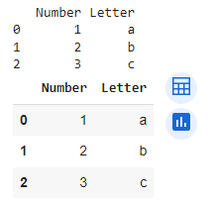

### 41.2 DataFrame from a Dictionary

import pandas as pd

data = {'Number': [1, 2, 3], 'Letter': ['a', 'b', 'c']}

df = pd.DataFrame(data)

print(df)

#Your code efficiently creates a DataFrame by providing a dictionary where the keys become column names, and the values become the data in those columns. This is a common and convenient way to create Pandas DataFrames for various data analysis tasks.

* **Number Letter**

**0 1 a**

**1 2 b**

**2 3 c**

### 41.2 DataFrame from a Series

s1 = pd.Series([1, 2, 3])

s2 = pd.Series(['a', 'b', 'c'])

df = pd.DataFrame({'Number': s1, 'Letter': s2})

#The keys ('Number' and 'Letter') are specified as the column names, and their corresponding values are the Series **s1** and **s2**.

df

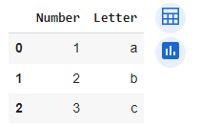

By understanding Series and DataFrames, you set the foundation for almost everything you'll do with Pandas, from data manipulation to advanced analysis.

## 42. Data Import and Export in Pandas

### Molecular Property Data

Now, let us import data on molecular properties. For this tutorial, We take the [solubility](https://raw.githubusercontent.com/GLambard/Molecules_Dataset_Collection/master/latest/ESOL_delaney-processed.csv) data from [Guillaume Lambard](https://github.com/GLambard). This file contains index column, so we add index_column=0.

import pandas as pd

url=”<https://raw.githubusercontent.com/GLambard/Molecules_Dataset_Collection/master/latest/ESOL_delaney-processed.csv>”

df = pd.read_csv(url, index_col=0)

# This line uses Pandas' **read_csv** function to read the CSV file from the specified URL. The **index_col=0** argument indicates that the first column in the CSV file should be used as the index (row labels) of the DataFrame.

df

**Output =>**

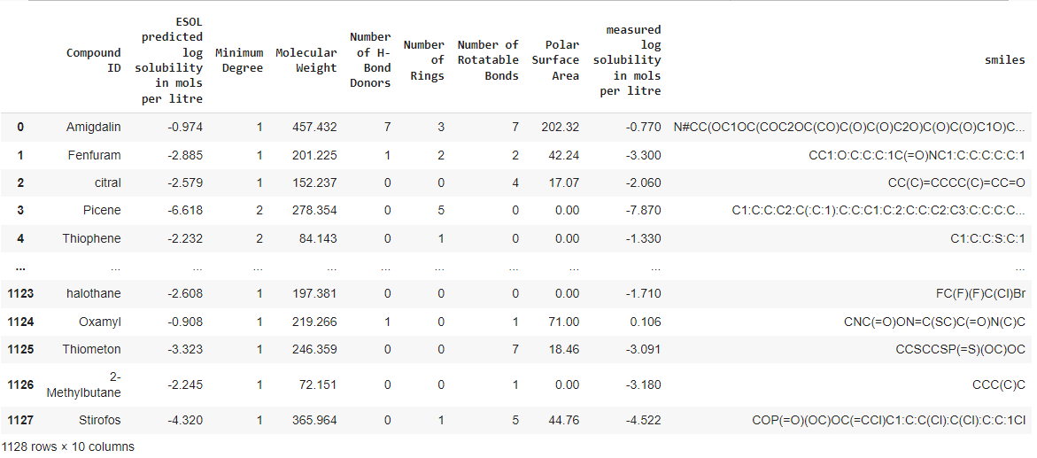

**Minimum Degree:**

Description: The minimum degree (number of edges connected to a node) in the molecular graph representation of the compound.  
Type: Numerical/Integer

**Smiles:**

Description: Simplified Molecular Input Line Entry System (SMILES) notation, representing the structural formula of the compound.  
Type: Categorical/String

### ESOL model

The ESOL (Estimated SOLubility) model is an empirical model designed to predict the aqueous solubility of organic compounds. It was developed by John S. Delaney and published in a 2004 paper titled "ESOL: Estimating Aqueous Solubility Directly from Molecular Structure". The model uses a set of molecular descriptors, such as molecular weight, number of atoms, and polar surface area, to estimate the log solubility (logS) of a compound in water.

The ESOL model is relatively simple and interpretable compared to more complex machine learning models. It is often used as a baseline or comparative standard in solubility prediction tasks. The model is particularly useful for screening large compound libraries in drug discovery and other chemical engineering applications, where quick and reasonable solubility estimates are needed.

## 43. Data Inspection

Now, we will see the effects of different commands in the above csv file.

df.head()

# displays the first 5 rows of the DataFrame, along with the column names.

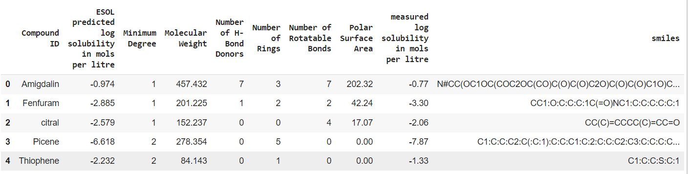

df.tail()

# displays the last 5 rows of the DataFrame, along with the column names.

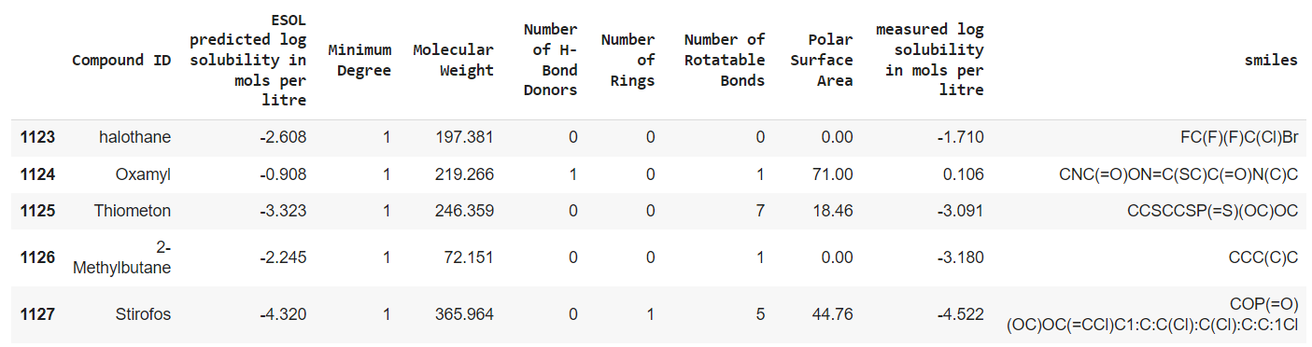

df.info()

#The **df.info()** method in Pandas provides a summary of the DataFrame's basic information, including the number of non-null entries, data types, and memory usage.

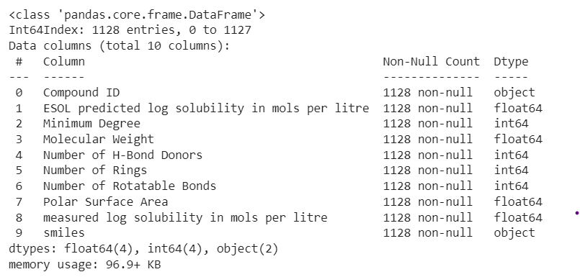

df.shape

#The df.shape attribute in Pandas returns a tuple representing the dimensions of the DataFrame.

* **(1128, 10)**

df.describe()

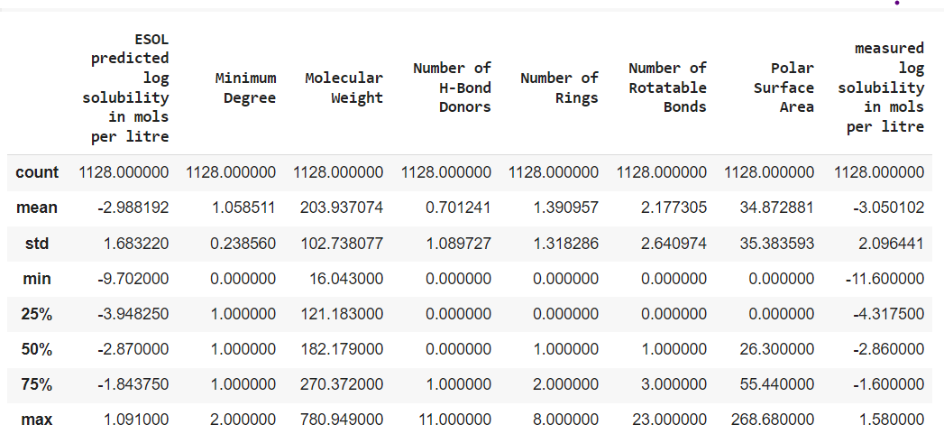

In this output:

* **count**: Indicates the number of non-null values in each numerical column.
* **mean**: Represents the mean (average) of each numerical column.
* **std**: Shows the standard deviation, a measure of the spread or dispersion of the data.
* **min**: Displays the minimum value in each column.
* **25%**, **50%**, and **75%**: These are quartiles, where the 25% quartile corresponds to the first quartile (Q1), the 50% quartile is the median (Q2), and the 75% quartile is the third quartile (Q3).
* **max**: Shows the maximum value in each column.

df.index

**#df.index** is an attribute in Pandas that allows you to access the index (row labels) of a DataFrame.

* **Int64Index([ 0, 1, 2, 3, 4, 5, 6, 7, 8, 9, ... 1118, 1119, 1120, 1121, 1122, 1123, 1124, 1125, 1126, 1127], dtype='int64', length=1128)**

If there was a name of index column, then output should look like:

* **Int64Index([ 0, 1, 2, 3, 4, 5, 6, 7, 8, 9, ... 1118, 1119, 1120, 1121, 1122, 1123, 1124, 1125, 1126, 1127], dtype='int64',name=<’name of the index column’>, length=1128)**

## 44. Row and Column Selection using iloc[] and loc[].

The loc[] method allows you to select rows and columns from a DataFrame based on their labels. Syntax: **DataFrame.loc[<row_labels>, <column_labels>]**

Features

**Label-based:** Uses the explicit index and column names for selection.

**Sliceable:** Allows slicing of rows and columns using their labels.

**Boolean Masking:** Can be used with boolean conditions to filter data.

Examples.

### 44.1. With loc[]

**Selecting a Single Row by Index Label:**

df.loc[1]

# When you use **df.loc[1]**, you are using the **.loc** indexer in Pandas to access a specific row in the DataFrame by its label. Here, label=1 means 2nd row.

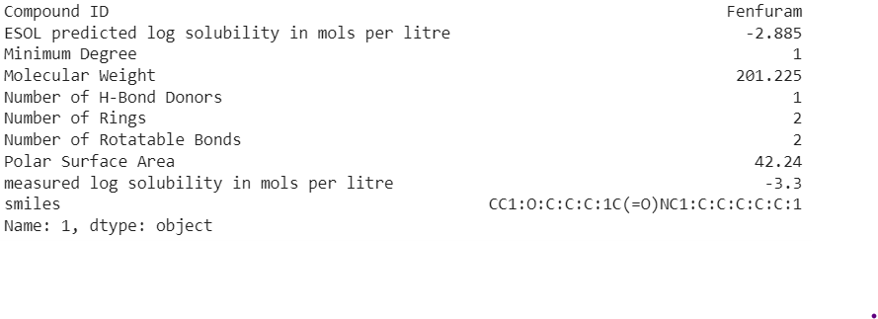

**Selecting Multiple Rows by Index Labels**

rows = df.loc[1:3]

rows

# you are selecting rows (index numbers) 1 to 3 (inclusive) from your DataFrame and creating a new DataFrame called **rows**.

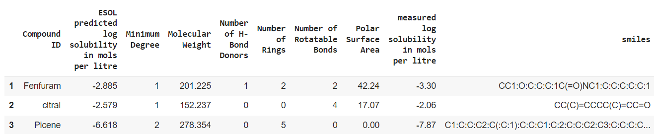

**Selecting Specific Columns with Rows**

A=df.loc[1:3, ['Compound ID', 'smiles']]

A

#Here, 'Compound ID', 'smiles' are column indices.

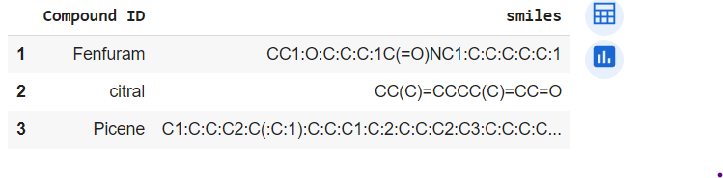

**Selecting columns**

B=df[['Compound ID', 'Molecular Weight']]

B

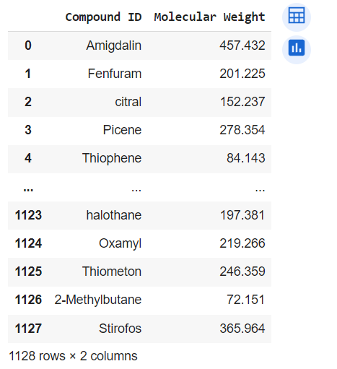

## 45. Difference between loc and iloc?

In Pandas, both **loc** and **iloc** are used to select specific rows and columns from a DataFrame, but they differ in how they are used to index and select data:

**loc (Label-Based Selection):**

**loc** is primarily label-based. It allows you to select data by specifying the row and column labels.

You can use actual labels or boolean conditions to filter data.

The ending index in a range is included in the selection. For example, df.loc[1:3] selects rows with labels 1, 2, and 3.

You can also use string labels to select specific rows and columns, like df.loc['row_label', 'column_label'].

**iloc (Integer-Based Selection):**

iloc is primarily integer-based. It allows you to select data by specifying row and column positions using integers.

It is similar to Python list indexing where the first element is at position 0.

The ending index in a range is not included in the selection. For example, df.iloc[1:3] selects rows at positions 1 and 2, but not 3.

You use integer positions to select specific rows and columns, like df.iloc[0, 1].

Here's a side-by-side comparison:

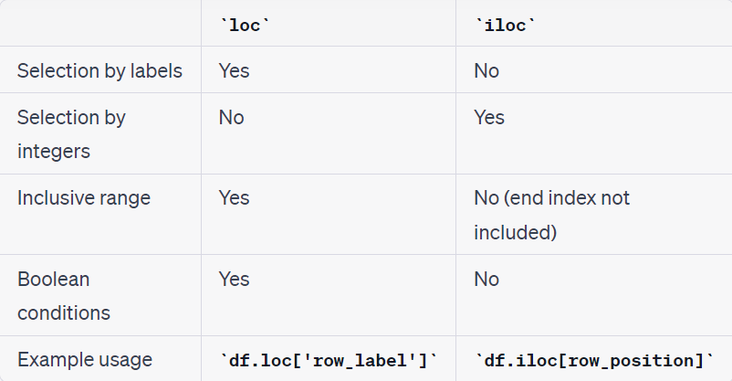

## 46. Selecting with iloc[]

Syntax:

DataFrame.iloc[<row_positions>, <column_positions>]

The iloc[] method allows you to select rows and columns from a DataFrame based on their integer positions. Features

**Position-based:** Uses the implicit integer index for selection.

**Boolean Masking**: Can be used with boolean arrays to filter data.

Examples:

**Selecting a Single Row by Position:**

df.iloc[4]

#Extract information of 5th row (index=4).

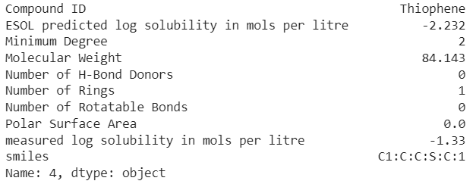

**Selecting Multiple Rows by Position**

df.iloc[0:3]

# Row no 4 (i.e., index=3) is excluded while we use iloc.

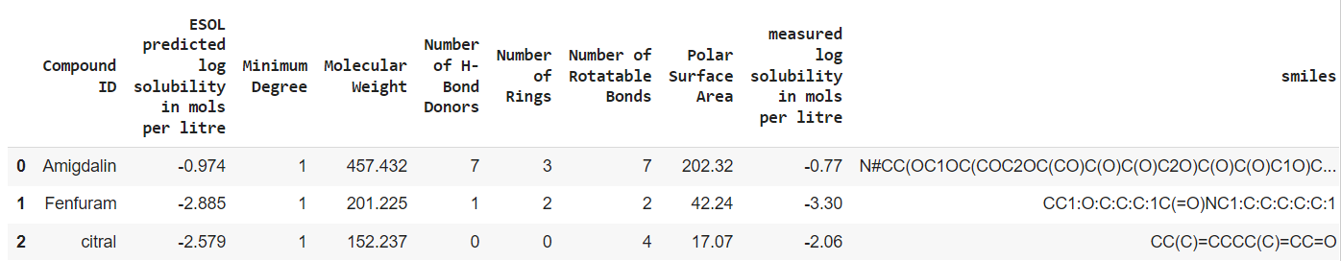

**Selecting Specific Columns with Rows**

df.iloc[0:3, 0:2]

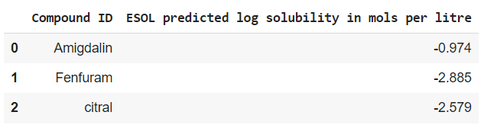

**Selecting Specific Cells**

df.iloc[0, 1]

* **-0.974**

### 46.1. To get a list of the column names.

df.columns

* **Index(['Compound ID', 'ESOL predicted log solubility in mols per litre', 'Minimum Degree', 'Molecular Weight', 'Number of H-Bond Donors', 'Number of Rings', 'Number of Rotatable Bonds', 'Polar Surface Area', 'measured log solubility in mols per litre', 'smiles'], dtype='object')**

## 47. Conditional Selection

### 47.1 Show how to filter rows based on column values.

**Question: How many molecules have more than five rings?**

condition = df['Number of Rings']>5

#This line creates a boolean Series **condition** where each element is **True** if the corresponding element in the 'Number of Rings' column is greater than 5, and **False** otherwise.

df[condition]

#it will give you a new DataFrame containing only the rows where the 'Number of Rings' is greater than 5.

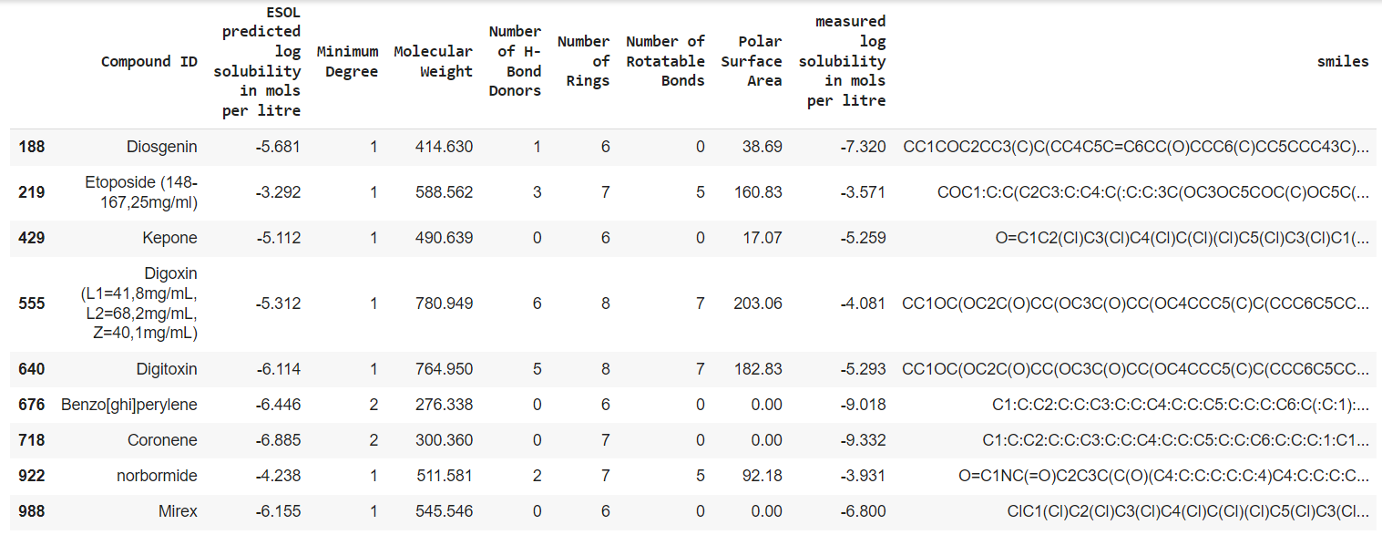

### 47.2 Conditional Selection with Multiple Conditions

condition = (df['Number of Rings'] >3) & (df['Number of H-Bond Donors']>3)

df[condition]

**Output =>**

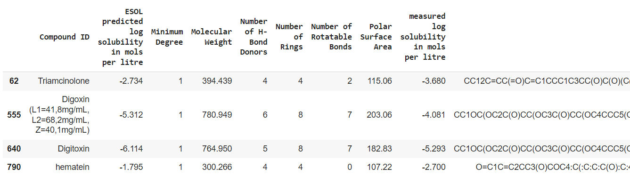

### 47.3. Which is the molecule with highest molecular weight?

condition = df['Molecular Weight'] == df['Molecular Weight'].max()

#df['Molecular Weight'] refers to the 'Molecular Weight' column in your DataFrame **df**. It creates a Pandas Series containing all the 'Molecular Weight' values.

df['Molecular Weight'].max() calculates the maximum value within the 'Molecular Weight' column. This is the largest value in that column.

df['Molecular Weight'] == df['Molecular Weight'].max() is a comparison. It checks each value in the 'Molecular Weight' column to see if it is equal to the maximum 'Molecular Weight' value. This comparison results in a boolean Series, where each element is **True** if the corresponding value in the 'Molecular Weight' column is equal to the maximum value and **False** otherwise.

df[condition]

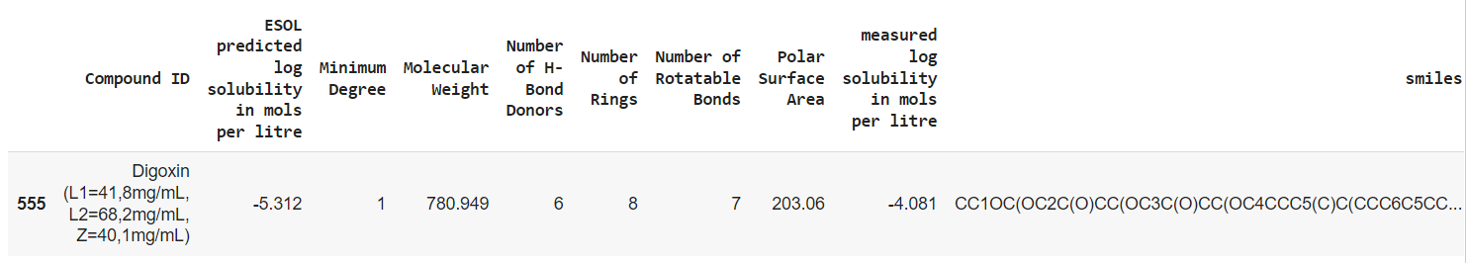

## 48. Resetting index

Let us set the index line of the DataFrame to the column named 'Compound ID'.

df_new = df.set_index('Compound ID')

#This line creates a new DataFrame called **df_new** with the index set to the values in the 'Compound ID' column. The original DataFrame **df** remains unchanged.

df.set_index('Compound ID', inplace=True)

#This line **modifies the original DataFrame df in place**, setting its index to the values in the 'Compound ID' column. This means that **df** will no longer have its default integer-based index, and the changes will be applied directly to **df** without creating a new DataFrame.

## 49. Matplotlib

### 49.1 Plot a graph for molecular weight vs log solubility.

import matplotlib.pyplot as plt

df.plot('Molecular Weight','measured log solubility in mols per litre')

*# This code creates a line plot (line chart). It connects the data points with lines, assuming a continuous relationship between the points. It's suitable for showing trends or patterns over a continuous range of values.*

df.plot('Molecular Weight', 'measured log solubility in mols per litre', kind='scatter')

#This code creates a scatter plot. A scatter plot displays individual data points as separate markers without connecting them with lines. It's useful for visualizing the distribution of data points, identifying outliers, and showing the relationship between two variables in a more discrete manner.

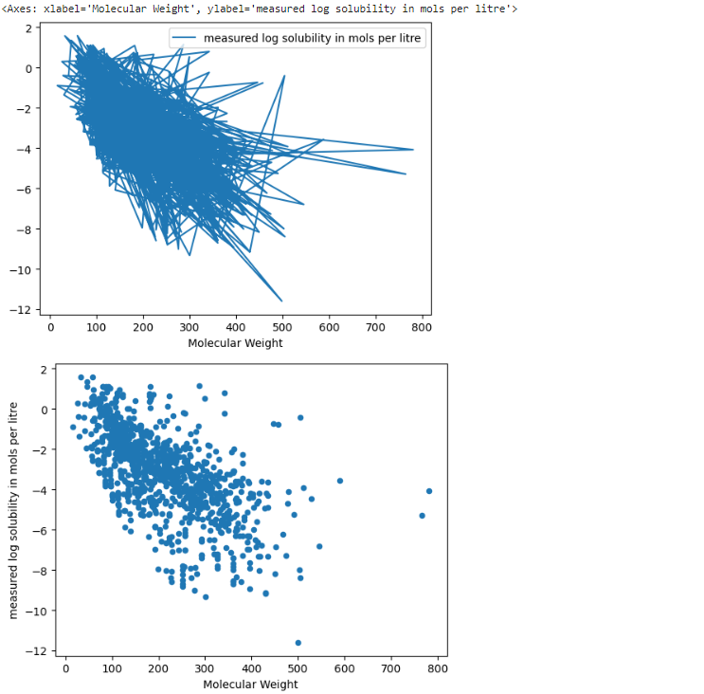

### 49.2 Make a histogram.

import matplotlib.pyplot as plt

# Sample data

data = df['Molecular Weight']

# Plotting the histogram

plt.hist(data, bins=10, edgecolor='black')  # Adjust the number of bins as needed

# Adding labels and title

plt.xlabel('Molecular weight')

plt.ylabel('Frequency')

plt.title('Histogram Plot')

# Display the plot

plt.show()

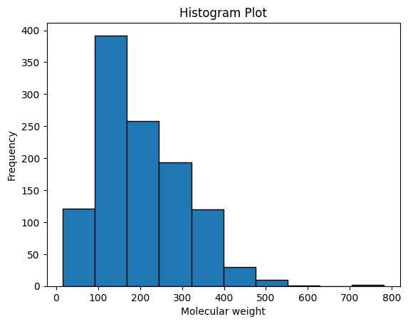

To make your histogram plot more visually appealing, you can add various customizations and visual enhancements. Here's an improved version of your code with added styling:

import matplotlib.pyplot as plt

**import seaborn as sns**  # Import seaborn for improved styling (you may need to install it)

# Sample data

data = df['Molecular Weight']

# Set up a Matplotlib figure with a specific size

plt.figure(figsize=(8, 6))

# 8-inch width and 6-inch height.

# Plotting the histogram with customizations

sns.histplot(data, bins=20, kde=True, color='skyblue', edgecolor='black')

# In Seaborn's sns.histplot() function, the kde parameter is used to control the display of a Kernel Density Estimation (KDE) plot overlay on top of the histogram. Setting kde=True means that you want to superimpose a KDE plot on your histogram. A KDE plot is a smoothed representation of the data's distribution and provides an estimate of the probability density function of the data. The peaks of the KDE curve correspond to regions of higher data density.

# Adding labels and title

plt.xlabel('Molecular Weight', fontsize=14)

plt.ylabel('Frequency', fontsize=14)

plt.title('Distribution of Molecular Weight', fontsize=16)

# Customize the axis labels and ticks

plt.xticks(fontsize=12)

plt.yticks(fontsize=12)

# Add a legend

plt.legend(["Data"], fontsize=12)

# Add a grid

plt.grid(axis='y', linestyle='--', alpha=0.7)

# Display the plot

plt.show()

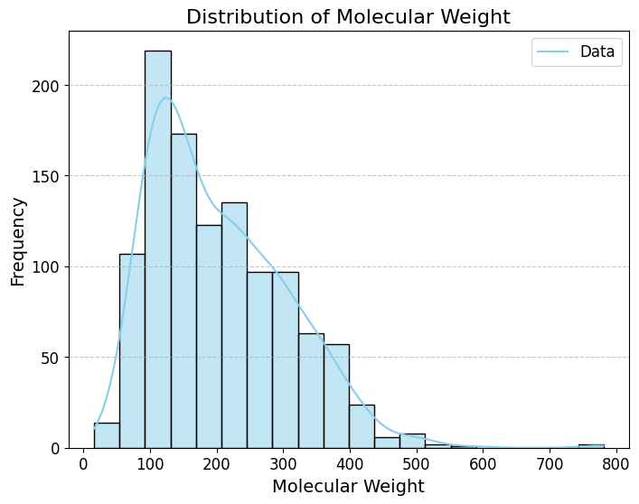

### 49.3 Linear regression plot

import matplotlib.pyplot as plt

import numpy as np

# Sample data

x = df['Molecular Weight']

y = df['measured log solubility in mols per litre']

# Perform linear regression (fit a line to the data)

coefficients = np.polyfit(x, y, 1)

# Use NumPy's **polyfit** function to perform linear regression (denoted by: 1). It fits a straight line (linear regression) to the data points and returns the coefficients of the line. In this case, **coefficients** will contain the slope (a) and the intercept (b) of the linear regression line.

a, b = coefficients

# Create a linear regression line

regression_line = a * x + b

*# Compute the values of the linear regression line using the coefficients obtained in the previous step. This line represents the best-fit linear relationship between the two variables.*

# Plot the data points

plt.scatter(x, y, label='Data Points')

# Plot the regression line

plt.plot(x, regression_line, color='red', label='linear')

# Add labels and title

plt.xlabel('Molecular Weight')

plt.ylabel('measured log solubility in mols per litre')

plt.title('linear Regression')

# Add a legend

plt.legend()

# Display the plot

plt.show()

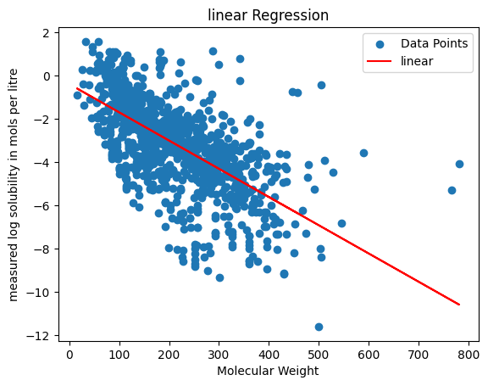

## 50. Machine Learning Assignment (By me)

**Assignment 08/11/2023**

In this work, **Glambard Molecules Dataset Collection** was used and various existing features were combined from the dataset to predict log solubility. Then, **Random Forest Regressor model** was trained to predict the 'measured log solubility in mols per litre' using the new feature and the normalized molecular weight.

The solubility of a compound can be influenced by various molecular properties. Let's discuss how the properties can affect the solubility of a compound:

**1. Molecular Weight:**

• Generally, higher molecular weight might reduce solubility as larger molecules tend to have stronger intermolecular forces that may hinder interactions with the solvent.

**2. Number of Hydrogen Bond Donors:**

• Molecules with more hydrogen bond donor groups (e.g., -OH, -NH) might increase solubility as they can form hydrogen bonds with the solvent, aiding in dissolution.

**3. Number of Rings:**

• A higher number of rings might decrease solubility as it can increase the molecule's overall size and reduce its flexibility, affecting interactions with the solvent.

**4. Number of Rotatable Bonds:**

• Compounds with many rotatable bonds could have reduced solubility since increased flexibility might hinder effective interactions with the solvent.

**5. Polar Surface Area:**

• Higher polar surface area might generally increase solubility as polar groups can interact favorably with the solvent through hydrogen bonding or other polar interactions.

Finally, we get **Mean Absolute Error= 0.7312687222924569**; which is a quite satisfactory value.

import pandas as pd

import matplotlib.pyplot as plt

import numpy as np

from sklearn.ensemble import RandomForestRegressor

from sklearn.model_selection import train_test_split

from sklearn.metrics import mean_absolute_error

from sklearn.metrics import mean_squared_error

#Imports necessary libraries for data handling (Pandas), visualization (Matplotlib), numerical operations (NumPy), machine learning model (RandomForestRegressor), splitting data for training and testing (train_test_split), and model evaluation metric (mean_absolute_error).

url = "https://raw.githubusercontent.com/GLambard/Molecules_Dataset_Collection/master/latest/ESOL_delaney-processed.csv"

df = pd.read_csv(url, index_col=0)

#Loads a dataset from the provided URL into a Pandas DataFrame. The index column is specified as 0th column.

# Molecular weight normalization

df['Normalized MW'] = df['Molecular Weight'] / np.mean(df['Molecular Weight'])

*# Normalizes the molecular weight values by dividing each value by the mean of all molecular weights in the dataset. This helps to ensure that the molecular weight feature is on a consistent scale with the other features.*

# Feature engineering

df['Other Properties'] =- df['Molecular Weight'] - df['Number of Rotatable Bonds']+df['ESOL predicted log solubility in mols per litre']-df['Number of Rings']+df['Number of H-Bond Donors']+df['Polar Surface Area']

# Data splitting

X = df[['Normalized MW', 'Other Properties']]

y = df['measured log solubility in mols per litre']

X_train, X_test, y_train, y_test = train_test_split(X, y, test_size=0.2, random_state=42)

# This code splits the data into two sets: a training set (**X_train** and **y_train**) and a test set (**X_test** and **y_test**). The **train_test_split()** function is used to split the data randomly, ensuring that both sets represent the distribution of the original data. 80% of the data is used for training (**X_train**, **y_train**), and 20% for testing (**X_test**, **y_test**).

# Model training with Random Forest

model = RandomForestRegressor(random_state=42)

model.fit(X_train, y_train)

*# Initializes and trains a Random Forest Regressor model using the training data (****X_train****,* ***y_train****).*

# Model evaluation

y_pred = model.predict(X_test)

mae = mean_absolute_error(y_test, y_pred)

rmse = np.sqrt(mean_squared_error(y_test, y_pred))

std_dev = np.std(y_test - y_pred)

print("Mean Absolute Error:", mae)

print("Root Mean Square Error (RMSE):", rmse)

print("Standard Deviation:", std_dev)

*# It uses the predict() method to make predictions for the test data and then calculates the mean absolute error (MAE) between the predicted values and the actual values. And finally, prints the mae.*

Output >>

Mean Absolute Error: 0.7312687222924569

Root Mean Square Error (RMSE): 1.0719598758851299

Standard Deviation: 1.0703410961313409

## 51. Latex Classwork (1/11/2023)

### 51.1. By sir

\documentclass[12pt]{article}

\usepackage{graphicx}

\title{ETSC \LaTeX}

\author{Sayak Karmakar}

\begin{document}

\maketitle

Hello! This is my first \LaTeX Document.

\section{Introduction}

This is a new paragraph.\\[12pt]

This is new line.

\section{Maths}

F=m a

$F = m a $

$y=x_1^2+x^2+3$

$$y=x_1^2+x^2+3$$

$\sqrt[3]{x^2+y^2}$

$$\sqrt{1+\sqrt{x^2}}$$

\begin{equation}

x = a + b

\end{equation}

\subsection{Greek Symbols}

Greek Symbols: $\alpha, \Pi$

Other: $\nabla, \delta, \Delta$

­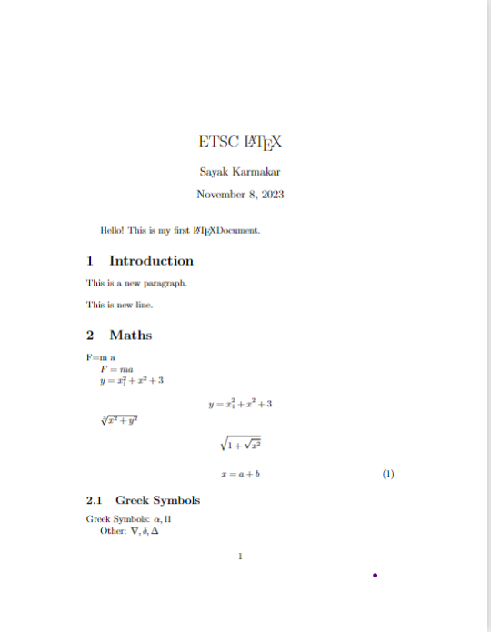

Fractions: $\frac{1}{2}$

$\int_a^b{x^2}dx$

$a_1, a_2, a_3,\ldots, a_{100}$

Trigonometric: $\sin x + \cos^2 x$

logarithmic: $\log_2 x, \log X, \ln x$

$$(a+b)^2$$

$$\left(\frac{a}{b}+b\right)^2$$

$$\sum{x^2}$$

$$\epsilon$$

Here, I am creating table \ref{tab:my_label}

\begin{table}[h]

\centering

\begin{tabular}{|c|c|c|c|c|}\hline

No & a & b & c &d \\\hline

1 & 2 & 3 & 4& 4\\\hline

2 & 4 & 5 & 6 & 2\\\hline

3 & 4 & 4 & 4& 3\\\hline

\end{tabular}

\caption{Caption}

\label{tab:my_label}

\end{table}

%These things for inserting figures.

\begin{figure}[h]

\centering

\includegraphics[width=0.2\linewidth]{Image/flower.jpeg}

\caption{Flower}

\label{fig:enter-label}

\end{figure}

%creating list

\begin{itemize}

\item item1

\item item2

\end{itemize}

Here is the reference \cite{DOI: 10.1021/acs.energyfuels.3c02680}

\bibliography{achs_enfuemAxA}

\end{document}

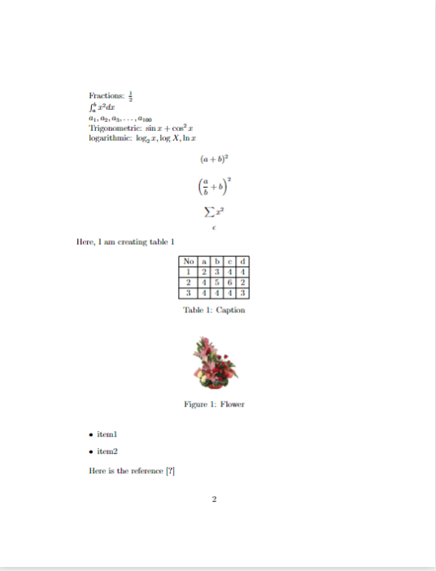

### 51.2 By me

\documentclass[14pt]{article}

\usepackage{graphicx, float} % Required for inserting images

\usepackage{amsfonts,amsmath, amssymb}

\title{Computational Hydraulics}

\author{Sayak Karmakar}

\date{November 2023}

\begin{document}

\begin{titlepage}

\begin{center}

\vspace*{5cm}

\Huge{\textbf{Computational Hydraulics}}\\

\Huge{\textbf{Governing Equations}}\\

\vfill

\Large{\textbf{-by-}}\\

\Huge {\textbf{Sayak Karmakar}}\\

\Huge {\textbf{Roll no: 22CE92R05}}\\

\today\\

\end{center}

\end{titlepage}

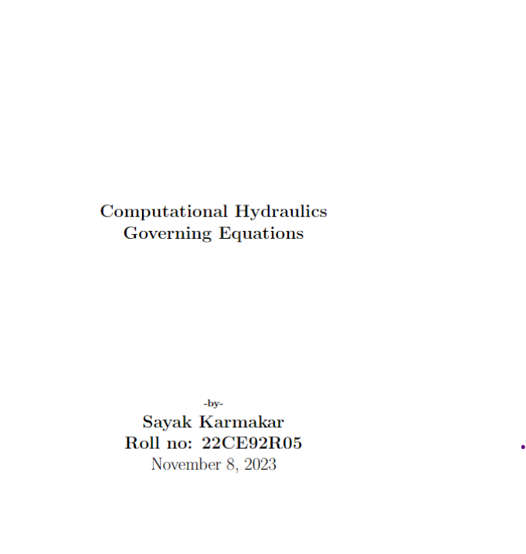

\tableofcontents

\thispagestyle{empty}

\clearpage

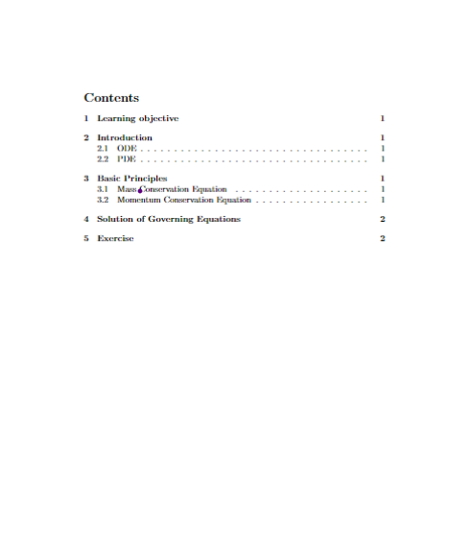

\setcounter{page}{1}

\maketitle

\section{Learning objective}

To identify Governing Equations for Hydraulic Systems.

\section{Introduction}

\subsection{ODE}

Differential Equation with ONE independent variable.

\subsection{PDE}

Differential Equation with two or more independent variables.

\section{Basic Principles}

\begin{itemize}

\item Conservation of Mass

\item Conservation of Momentum

\item Conservation of Energy

\end{itemize}

\subsection{Mass Conservation Equation}

\begin{equation}

\frac{\partial u}{\partial x}+\frac{\partial v}{\partial y}+\frac{\partial w}{\partial z}=0

\end{equation}

\subsection{Momentum Conservation Equation}

\begin{equation}

\frac{\partial u}{\partial t}+\frac{\partial uu}{\partial x}+\frac{\partial uv}{\partial y}+\frac{\partial uw}{\partial z}=-\frac{1}{\rho}\frac{\partial P}{\partial x}+ g_x+\frac{\mu}{\rho} \left(\frac{\partial^2 u}{\partial^2x}+\frac{\partial^2 u}{\partial^2y} +\frac{\partial^2 u}{\partial^2z}\right)

\end{equation}

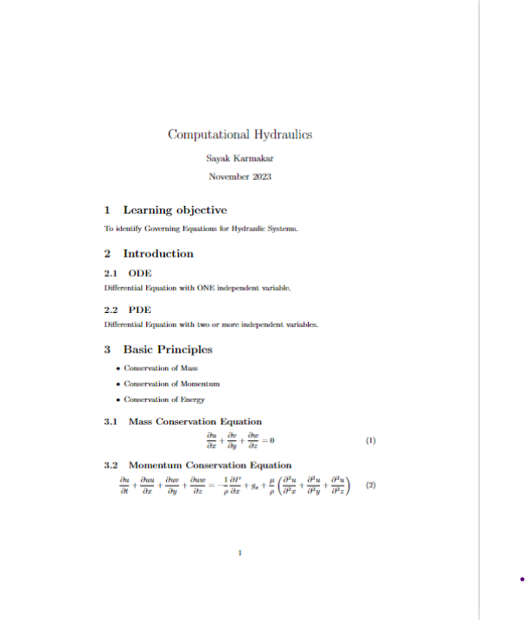

\section{Solution of Governing Equations}

Solution of Governing Equations in computational Hydraulics are of two types i.e. Implicit and Explicit. Difference between these two are described below in table \ref{tab:my_label}

\begin{table}[h]

\centering

\def\arraystretch{1.5}

\begin{tabular}{|p{4cm}|p{4cm}|p{4cm}|}\hline

Aspect & Implicit Solution & Explicit Solution\\\hline

Numerical Stability & Stable for a wider range of time steps. & Can be conditionally stable based on the CFL (Courant-Friedrichs-Lewy) condition, limiting the time step for stability.\\\hline

Time Dependency & Computationally more expensive due to solving nonlinear systems of equations at each time step, suitable for stiff systems. & Computationally less expensive since the solution progresses explicitly through time, applicable for simpler systems or those that are not stiff.\\\hline

Convergence & Requires iterative methods for convergence, often using techniques like Newton-Raphson, Gauss-Seidel, or other matrix solvers. & Does not require iterative solving and typically proceeds directly to the solution at the next time step.\\\hline

\end{tabular}

\caption{Difference between Implicit and Explicit Solutions}

\label{tab:my_label}

\end{table}

\section{Exercise}

Estimate the depth of the channel reach for different section using implicit algorithm.

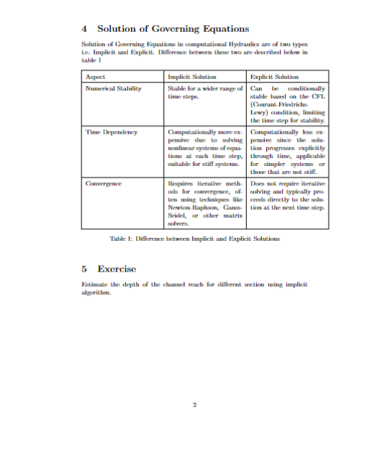

\begin{figure}[H]

\centering

\includegraphics[width=1.0\linewidth]{image/Assignment_Channel.png}

\caption{Channel with rough bed}

\label{fig:enter-label}

\end{figure}

\end{document}

